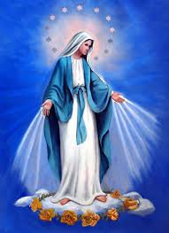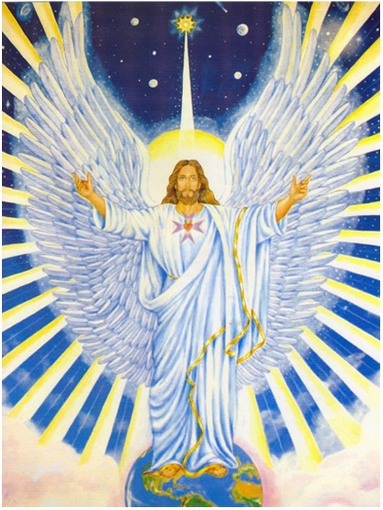

Mother Mary Regina Jesus -Micah, Cosmic Archangel of Unity

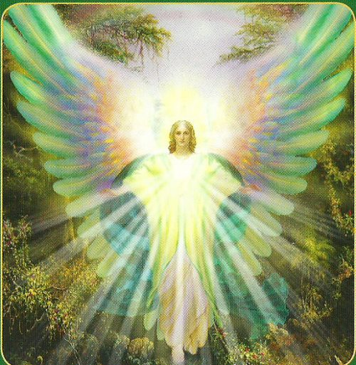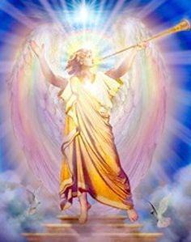
Archangel Raphael Archangel Gabriel

TEMPLE OF THE RESURRECTION
TRANSMISSION FLAME SERVICE
March 15 - April 14, 2020
10:00 WELCOME ( Time given is Eastern Daylight Time – New York USA)
10:01 ACOLYTE SERVICE: LIGHTING THE CANDLES
ALL SAY:
(While the candles are lit, appropriate music may be played, such as “Bells of the Meadow”.)
“All hail to Thee, Thou Mighty All-Pervading Light of the Universe, the Supreme Source of all Life, I AM! We kneel within our Hearts in recognition of the GREAT Light of the Cosmos, as we draw forth these Flames representing the Three-Fold Activity of Life as exemplified by the Holy Trinity: the Father (lighting blue candle), the Son (lighting yellow candle), and the Holy Spirit (lighting the pink candle).” (After candles are lit, continue.)
“Beloved Cosmic I AM Presence come now and assert Thy Rightful Authority in the four lower vehicles of ALL Thy children, and show us how to reverently and humbly express the perfectly balanced activity of Love, Wisdom, and Power which Thou art.
“Oh Light Supreme! We acknowledge Thee in all Life, and we give Gratitude to the Glorious Cosmic and Ascended Beings, as we invoke Them and the Great Angelic Host to amplify the energy which we release in this class, and may that Light expand, expand, and expand as it travels throughout the Universe, ever widening the Borders of Thy Kingdom, in fulfillment of Thy Will, I AM!”
10:05 INVOCATION:
Through the Love of My “I AM Presence”, I call on the Great White Brotherhood assembled now at the Resurrection Temple and especially to Beloved Jesus - The Cosmic Archangel of Unity and Mother Mary, Archangels Raphael and Gabriel. Establish in, through, and around all who participate today throughout the world in these Transmission Flame Classes the FULL POWER AND GLORY of the Flame of Resurrection, in an ever-expanding Radiance. Raise all Life evolving on this planet and its atmosphere into the realm of Divine Consciousness, and hold it there forever.
I call directly on Archangel Michael, K 17, Mighty Astrea, the Elohim of Purity, the Maha Chohan, Saint Germain, Archangel Zadkiel, Elohim Arcturus and Holy Amethyst, and The Great Divine Director to place a Shield of Invincible Protection around all classes participating in this Service and to Transmute and Purify all energies of a discordant nature. I also call on These Beloved Ascended Beings to see that these Transmission of the Flame Services, will be held forever in the future in the Spirit and according to the Purpose originally envisioned by the Beloved Maha Chohan in 1952.

10:07 CHARACTERISTICS OF RETREAT
Name of Retreat: Resurrection Temple.
Retreat is open April 15 through May 14 this year 2019.
Location: Etheric Realm over the Holy Land.
Hierarch: Beloved Jesus-Archangel of Unity and Mother Mary; Archangels Raphael and Gabriel.
Primary Function: The Action of the Resurrection Flame is the quickening of the vibratory action of the Light of Life within the cells of the body, enabling the Inner Light to throw off the appearance of limitation and stand revealed in the "Glory it had with the Father, before the world was."
Color of the Flame: Mother of Pearl in the shape of an Easter Lily
God-quality of the Flame: Restoration and Resuscitation—to nourish mankind and the nature kingdom with the life-essence and restoring power of the flame
Keynotes: “Ave Maria (keynote of the retreat); “Whispering Hope (keynote of Mary and Raphael); “Joy to the World” (Keynote of Jesus). “Sleepers Awake” (J. Bach)

10:10 WORLD-WIDE PATH OF FLAME: (see map). Group director describes the world-wide path of the Truth Flame, starting at the Holy land and proceeding in a West-to-East direction.
10:12 PURPOSE OF TFS: Students, by performing the Rhythmic Breath, are magnetizing and radiating the specific God-Quality of the open Retreat into the lower vibrations in which mankind abides. The students are acting as a stepped-down transformer, and the particular God-Quality of the retreat is absorbed by the four lower bodies of all mankind. The TFS is the most effective way to increase the Light-quota of the Earth.
10:17 VIOLET FLAME VISUALIZATION: (Use music selection “The Blue Danube.”)
Group director, while music is playing, gives the following guided visualization.
Visualize a Violet Ray coming towards you from the realms above.
See the Violet Ray becoming a Violet Flame, 3 ft below you.
See the Violet Flame going upwards, surrounding your entire physical body.
See the Violet Flame expand and cover this sanctuary.
See the Violet Flame expand and cover the town (city) you live in, your state, and your country. See the Violet Flame expand and cover your continent, and finally
See the Violet Flame expand and surround the entire planet, and hold it there.
10:20 SONGS TO EL MORYA AND SAINT GERMAIN: (AMTF Songs and Decrees: 45 &46 or 49 & 50)
10:27 DESCRIPTION OF THE RESURRECTION TEMPLE (source: Journal Bk.1:168-172)
In the Near East, shining in the pulsating ethers over the Holy Land, stands the Temple of the Resurrection, whose Immortal Flame of Restoration and Resuscitation is guarded and protected by the Hierarchs. It is an exquisite circular temple of blazing substance that is self-luminous and radiates the tones found within the “Ave Maria.” The Temple is composed of seven circular corridors around a central altar from which pulsates the white fire of the Resurrection Flame in the form of a great white Easter lily. The angel devas, cherubic, and seraphic Hosts of the Flame are constantly absorbing Its substance into themselves and then sweeping outward at the direction of the Masters in charge of the Light ray.
The Temple provides a focus for the directors of the forces of nature and the lovely elementals, representing the four kingdoms (fire, air, water, and earth), who play in the atmosphere and aura of this temple at all times. The radiation of the Resurrection Temple is like a glorious rainbow of colors, and the visitation to it by those God-Beings, interested in developing the capacity to resurrect the divine plan on this Earth, adds to its great beauty and Light.
Another focus of the Temple is the continual pouring into the emotional, mental, etheric, and physical consciousness of all the evolutions belonging to Earth, the reality of the actual power of resurrection within life itself. Thus, those Brothers and Sisters who abide within the Resurrection Temple and direct that Flame through the lower bodies of the neophytes, in answer to their individual invocations for its tremendous Power to be loosed through them and others. Into that Flame has stepped every lifestream who achieved the Victory of the Ascension from the humanity of Earth.
The degree of Mastery and Light achieved by each Brother and Sister belonging to this Temple determines how near they may draw to the Central Sanctuary, the Holy of Holies, because the power of this Flame is such that only Ascended Beings can stand in its Presence. However, many chelas occupy the outer Chambers, and gradually, through proximity and through individual application, prepare themselves to approach closer and closer to the Heart Centre where the focused Flame abides.
Each of the seven circular corridors receives the radiation of the flame, mercifully dimmed so that its light and essence may be absorbed and digested by the beings who serve within that sphere of activity. In each such corridor a Master of Wisdom instructs a group of chelas, who are engaged in the service of learning how to draw this flame, and to project it toward a given objective. They hold the beam of their attention, as the channel and guide, along which the Light flows into churches, shrines, hospitals, homes, and human hearts.
One of the corridors is devoted entirely to directing the Resurrection Flame into the etheric realm and through the etheric bodies of those who have applied, through their own heart flame, for purification of their own etheric records.
In another circular room, with the willing cooperation of the angelic host, the Brothers and Sisters direct the flame with the assistance of the Master who guides them, into the astral and psychic realms, rendering tremendous assistance in dissolving the mass accumulations of discord, which manifest as diseases of mind and body.
From another one of these great circular rooms, the Brothers and Sisters direct the flame through the vast sea of the emotional realm and through the desire worlds of those who wish to rise above the passions of the senses,

From still another room, the directors of the light rays pour the flame into the vibratory action of the mental bodies of the race and through the tremendous accumulation of thoughtforms which fill the atmosphere,

In the outermost court of the temple are the Brothers and Sisters who direct the Flame through the physical structure of those who desire bodies that are absolutely non-recordant to disease. From this court, also, the nature devas and the elemental builders of form, under the direction of the Maha Chohan, supervise the direction of the rhythmic currents of the Resurrection Flame, that provide the seasons of growth and harvest.

The Resurrection Flame was first drawn into the atmosphere of the Earth Planet by the Great Krishna, who, seeing the shadow of human thought and feeling taking form in the consciousness of humanity, knew that the fruit of that seed would be disease, disintegration and decay, and knew further that some means of restoration of these fallen Sons of God would have to be provided for, in case they desired to return to their natural God Estate.
As the Great White Brotherhood freely partake of the gifts and blessings of the Resurrection Temple, as well as share in their distribution and as the mankind of earth are invited to become the guests of the beloved Masters who guard and sustain the flame, there is a tremendous opportunity to those who choose to avail themselves of its restorative powers by the opening of their inner bodies, as well as their physical bodies, to the transmuting, quickening, raising power, which is provided by the God of love for those who choose to accept its blessings and incorporate its power into their individual lives and worlds.
Through the centuries. The Maha Chohans of each age have availed themselves of the tremendous power of the Resurrection Flame. As the Spring sunshine stirs the dormant life within the nature kingdom, our Lord Maha Chohan sends forth the pulsation of the Resurrection Flame through the Earth and obedient life responds, “rising from the dead” in the miracle of Spring.
Beloved Ascended Master Jesus endeavored to show mankind that what nature can do, man also can do! He, therefore, submitted his undefiled physical body to so-called : “death”: and then, through the invocation of this Resurrection Flame, he brought life back from the same body as an example to all mankind that what can be done by a flower, a shrub, or a tree, can also be done by members of the human race.
10:32 Play keynotes of the retreat and their sponsors: “Ave Maria,” (selection 5),” Whispering Hope” (selection 6) and “Joy to the World.” (selection 7).
10:39 Practice session in preparation for the actual Transmission of the Flame. The practice session serves the student to become familiar with performing several activities at the same time, namely the Rhythmic Breath together with the monthly statement and visualization. Explain Rhythmic Breath.
Breathe deeply and slowly, drop shoulders, all breathing done through both nostrils and mouth closed.
Inbreathe for a count of 8
Hold for a count of 8
Exhale for a count of 8
Hold for a count of 8
(Practice entire sequence 6 times.)
10:44 Combine rhythmic breath with monthly breathing statement. As the group director leads the rhythmic breath, the entire group listens to the monthly statement, which is
“I AM INBREATHING from Jesus and Mary the raising power of the Resurrection Flame.”
“I AM ABSORBING from Jesus and Mary the raising power of the Resurrection Flame."
“I AM EXPANDING from Jesus and Mary the raising power of the Resurrection Flame."
“I AM PROJECTING from Jesus and Mary the raising power of the Resurrection Flame.
(Practice entire sequence 6 times.)
10:48 Combine rhythmic breath with monthly statement and visualization.
During “inbreathing,” visualize Flame of Resurrection coming toward you from a westerly direction.
During “absorbing,” visualize the Flame of Resurrection entering your four lower bodies. Become one with the flame.
During “expanding,” visualize the Flame of Resurrection proceeding out of your bodies to the retreat east of you, or to the Goddess of Liberty in the New York Harbor, adding your love and light.
During “projecting,” visualize the Flame of Resurrection going to the Temple of Liberty in France, and then circling the globe in a West-to-East direction. (The Flame circles the globe in one minute.)
“I AM INBREATHING from Jesus and Mary the raising power of the Resurrection Flame.”
“I AM ABSORBING from Jesus and Mary the raising power of the Resurrection Flame."
“I AM EXPANDING from Jesus and Mary the raising power of the Resurrection Flame."
“I AM PROJECTING from Jesus and Mary the raising power of the Resurrection Flame.
(Practice entire sequence 6 times.)
10:52 Group rises and says in unison: “I AM a Holy Vessel through which the Ascended Host is pouring the God-quality of the Resurrection Temple.” ( X3)
10:53 Contemplative Music or Keynote Music of the Open Retreat is played to bridge the time to 11.00 AM, New York time. (Use selection 10– “Thais”.)11:00 At exactly 11.00 AM, New York time, actual Transmission of The Flame. (Use monthly statement). Listen to monthly breathing statement (given 12 times), accompanied by rhythmic breathing, visualization, and the DEEPEST feelings of Restoration and Recitation within the Flame.
“I AM INBREATHING from Jesus and Mary the raising power of the Resurrection Flame.”
“I AM ABSORBING from Jesus and Mary the raising power of the Resurrection Flame."
“I AM EXPANDING from Jesus and Mary the raising power of the Resurrection Flame."
“I AM PROJECTING from Jesus and Mary the raising power of the Resurrection Flame.
11:06 Visualize and feel the Flame and its color circling the globe for 10 minutes. (Use the “Visualization of the Flame” selection 12.)
11:16 Seal the activity, and protect it by singing “To the Seven Archangels.” (Songs, Decrees & Services – www.iamfree.co.za)
ELEVATION OF THE CRYSTAL CUP
ALL STAND
THE GROUP SAYS TOGETHER
In the Name and by the Power of the Almighty I AM vested in us, we, your chelas, call to you, our beloved Holy Aeolus, Beloved Mother Mary, Beloved Archangel Gabriel, and Beloved Micah, the Angel of Unity, as we raise this crystal cup to be filled with the Holy Essence of the Christ. We also raise the chalice of our consciousness, each and every one of us. Let the golden elixir of the Cosmic Christ enter. Fill it to the brim with this Essence, the Holy Elixir of the Light, the all -pervading Light of the Cosmos. Fill this Holy Grail with the Christ Consciousness.

THE GROUP LEADER ELEVATES A CRYSTAL CUP AND ALL SAY THE VEDANTIC PRAYER:
Oh, thou Infinite Holy Presence of God, the Divine Source of All Life! Hallowed be thy sacred Name! We bow before thee in gratitude, praise, and thanksgiving for thy Supreme Presence in the universe, because thou art, I AM!
We return to thee, Almighty One, all the power and dominion which we have ever vested in any imperfect manifestation, visible or invisible, for thou art the all power of the universe, and there is no other power that can act. Let thy Will be done in us now. Let Thy kingdom be manifest across the face of this earth through the hearts of all who are so blessed as to live upon it.
Oh, Supreme Beloved One, as we lift our hearts, our vision, our consciousness toward thee, release the substance of thy Self to us each, according to our requirements, that as we move forward in thy name and upon thy service, we shall not be found wanting.
We ask forgiveness for all the transgression of thy Law of Love and Harmony, both for ourselves and all humankind, the forces of the elemental kingdom, and the kingdom of nature. Endow us, now, with the power and desire to so forgive all who have ever caused us distress, back unto the very beginning of time.
Because thou art with us and in us, we fear no evil, for there is no power apart from thee which can hurt, destroy, or despoil Life’s beauty of expression. Thou art the strength and the power by which we move ever in the Path of Righteousness, and now — Oh Father of Light — show us the full glory we had with Thee in the beginning before the world was.
So be it. (KRISHNA)
ELEVATED CUP HELD 1 MINUTE IN SILENCE WHILE SACRED MUSIC PLAYS

11:19 BENEDICTION: All say: “Mighty I AM Presence assert and hold your dominion to help each one to understand your marvelous laws that all may maintain perfect harmony, perfect health, and produce perfection. For your enfolding presence, protecting power, intelligence, and love, we thank you!”
11:21 EXTINGUISH CANDLES
We return these flames to the Great Central Sun from whence they came, with all our love, blessings and gratitude for life everywhere.
Extinguishing the pink candle. Extinguishing the yellow candle. Extinguishing the blue candle.

