TRANSMISSION OF THE FLAME SERVICE
FOR THE TETON RETREAT

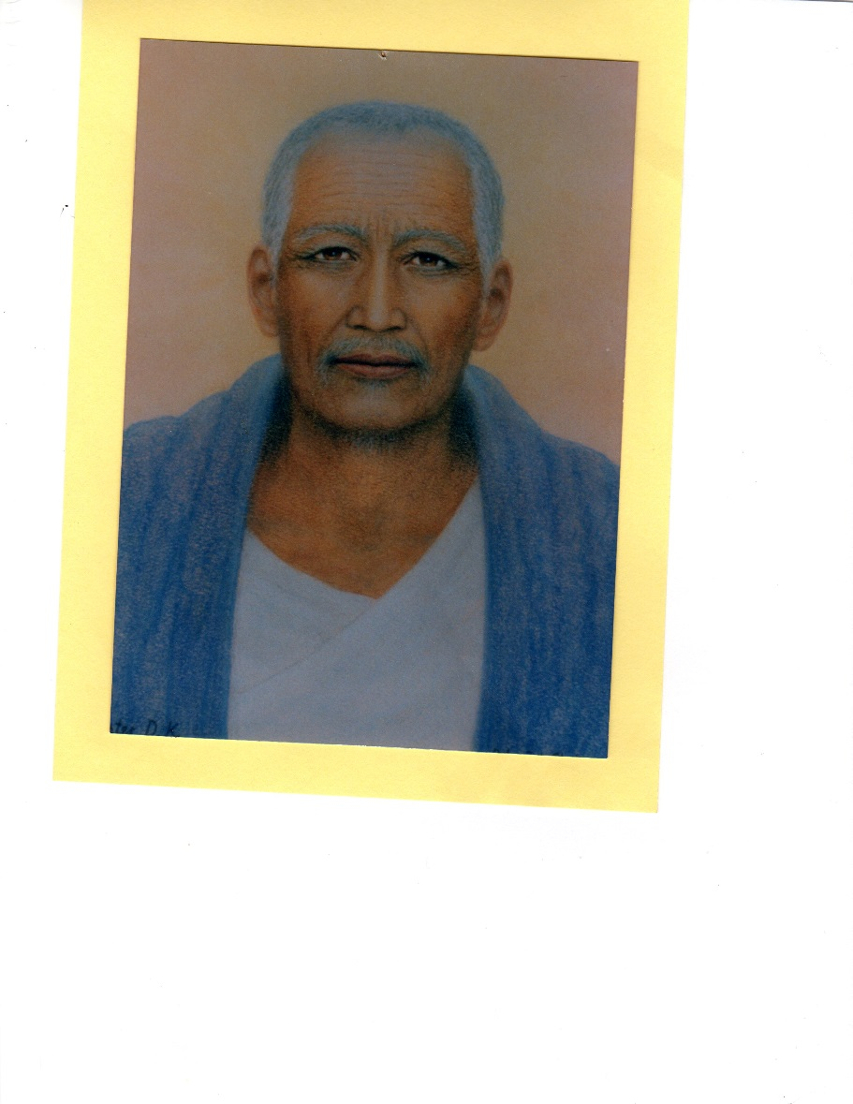
BELOVED DJWAL KUL
HIERARCH OF THE TETON RETREAT

10:00 WELCOME
10:01 ACOLYTE SERVICE: LIGHTING THE CANDLES
ALL SAY:
(While the candles are lit, appropriate music may be played, such as “Bells of the Meadow”.)
“All hail to Thee, Thou Mighty All-Pervading Light of the Universe, the Supreme Source of all Life, I AM! We kneel within our Hearts in recognition of the GREAT Light of the Cosmos, as we draw forth these Flames representing the Three-Fold Activity of Life as exemplified by the Holy Trinity: the Father (lighting blue candle), the Son (lighting yellow candle), and the Holy Spirit (lighting the pink candle).” (After candles are lit, continue.)
“Beloved Cosmic I AM Presence come now and assert Thy Rightful Authority in the four lower vehicles of ALL Thy children, and show us how to reverently and humbly express the perfectly balanced activity of Love, Wisdom, and Power which Thou art.
“Oh Light Supreme! We acknowledge Thee in all Life, and we give Gratitude to the Glorious Cosmic and Ascended Beings, as we invoke Them and the Great Angelic Host to amplify the energy which we release in this class, and may that Light expand, expand, and expand as it travels throughout the Universe, ever widening the Borders of Thy Kingdom, in fulfillment of Thy Will, I AM!”

10:05 INVOCATION:
Through the Love of My “I AM Presence”, I call on the Great White Brotherhood assembled now at the Teton Retreat and especially to Beloved Djwal Kul, Confucius, and Lanto. Establish in, through, and around all who participate today throughout the world in these Transmission Flame Classes the Full power and glory of the Flame of Precipitation, in an ever-expanding Radiance. Raise all life evolving on this planet and its atmosphere into the realm of Divine Consciousness, and hold it there forever.
I call directly on Archangel Michael, K 17, Mighty Astrea, the Elohim of Purity, the Maha Chohan, Saint Germain, Archangel Zadkiel, Elohim Arcturus and Holy Amethyst, and the Great Divine Director to place a shield of invincible protection around all classes participating in this service and to transmute and purify all energies of a discordant nature. I also call on these beloved Ascended Beings to see that these Transmission of the Flame services, will be held forever in the future in the spirit and according to the purpose originally envisioned by the beloved Maha Chohan in 1952.

10:07 CHARACTERISTICS OF RETREAT
Name of Retreat: Teton Retreat.
Retreat is open: June 15 through July 14 of each year. It is also open from December 15 through January 14 of each year.
Location: Rocky Mountains, Wyoming, USA.
Hierarchs: Beloved Djwal Kul.
Primary Function: To Bring into manifestation the Divine Plan for the Earth, and have sincere chelas gain in spiritual development. To assist the Sixth Root race in establishing a highly-developed civilization in South America. The Brothers of the Golden Robe, stationed in Kashmir, India, are assisting in this task.
Color of the Flame: Chinese green with golden radiance
God-quality of the Flame: To intensify the power of precipitation and to bring God-ideas into manifest, physical, practical forms.
Symbol of the Retreat: Flame takes the form of a tulip
Keynote: “Evening Star” (selection 5)
10:10 WORLD-WIDE PATH OF FLAME: (see map). Group director describes the world-wide path of the Flame, starting at the Teton Retreat and proceeding in a West-to-East direction.
10:12 PURPOSE OF TFS: Students, by performing the rhythmic breath, are magnetizing and radiating the specific God-Quality of the open Retreat into the lower vibrations in which mankind abides. The students are acting as a stepped-down transformer, and the particular God-Quality of the retreat is absorbed by the four lower bodies of all mankind. The TFS is the most effective way to increase the Light-quota of the Earth.
10:17 VIOLET FLAME VISUALIZATION: (Use music selection “The Emperor’s Waltz,” selection 2)
Group director, while music is playing, gives the following guided visualization.
Visualize a Violet Ray coming towards you from the realms above.
See the Violet Ray becoming a Violet Flame, 3 ft below you.
See the Violet Flame going upwards, surrounding your entire physical body.
See the Violet Flame expand and cover this sanctuary.
See the Violet Flame expand and cover the town (city) you live in, your state, and your country. See the Violet Flame expand and cover your continent, and finally
See the Violet Flame expand and surround the entire planet, and hold it there.
10:20 SONGS TO EL MORYA AND SAINT GERMAIN: (AMTF Songs and Decrees: 45 &49 or 46 & 50)
10:27 DESCRIPTION OF THE TETON RETREAT
Rising majestically from the plains of Wyoming, the snowcapped cathedral - like spires of the Grand Teton Mountains stimulate awe, reverence and admiration of their magnificent splendor, in even the most casual observer.
Above the Tetons is the great Amphitheater. It is done in the deep emerald green. It is a complete circle with occasional openings through which the separate groupings of people enter
Within the Grand Teton, a Focus of the Great White Brotherhood has been sustained through the ages, dedicated and consecrated to the development and externalization of the Divine Plan for the Earth, humanity and all attendant Life evolving within and upon the Planet. The First Root Race built the Teton Retreat
Twice each year, the Spiritual Hierarchy meet in Council in the heart of the Grand Teton, each Member bringing some particular idea which could be of benefit to the progress of the race, in cooperation with the designed pattern for the twelve-month cycle in which such Councils take place.
Seven chambers, arranged like the petals around a flower, were fashioned out of the mountain. A large room which is the Council Chamber is now the center for the stamen of the flower. In design and architecture, the Teton looks something like a sunflower. The Council Chamber is about two hundred feet in length and about half that size in width, with a ceiling of great height. In the ceiling is a Golden Disc whose center is a seven pointed Star of Golden Light composed of yellow diamonds. Surrounding this are seven discs representative of the seven major Planets of our system, through which are released spiritual currents through the seven ganglion centers of the entire race. The colors of these discs are of the clearest and most vibrant shade representative of their Ray. At the far end of the Council Chamber is a representation of the All-Seeing Eye of God, symbolizing that the Supreme Source is watching over his children and that all is known to him.
The seven chambers are not opened except at times of great crisis and at the time of the yearly councils. Gold mesh curtains prepared in Persia and India hang at the entrance of the seven chambers. On each side, when opened, are the Archangel and Archii of that Ray.
In China, the magnificent Central Altar was fashioned, and it is made of very beautifully carved ivory. It is in the center of the central chamber. Into those ivories are embossed the Story of Creation in little gold plaques, beginning with the coming of Lord Michael, the Manu, and the First Root Race. It is a most magnificent piece of work. Around the top of this circular platform is a looping of gold, going all the way around it. Woven into it is a Chinese green vine and yellow calla lilies.
In the center is a beautiful brazier to hold the Flame of Precipitation; its entire body is made of clear jade that you can almost look through. The Cup itself is composed of thousands of magnificent emeralds. Within that burns the glorious Flame whose center is gold and the outer Radiation is green.
At the Altar, around Beloved Djwal Kul, the Radiation and the Aura are tremendous because his concentration duplicates instantly that which is there. And it is held within His Aura. Even the greatest Beings present wait for the signal before they begin to project those little Flames forth. Imagine what happens when Beings like Sanut Kurara, Lord Maitreya, and others are visualizing that Flame which manifests as Precipitation and the Power of Expression, and then all sending forth those thought forms perfectly into the lower atmosphere of Earth! Those little thought forms sweep out, as soon as the breathing begins, and anchor into the consciousness, the mental, and the feeling world of mankind. First, to the students because they fly like a magnet to that to which they are attracted. The students’ attention attracts them, and then they fly throughout the world.
Each earnest student is encouraged to make a heart call to the Christ Self of every member of the race, discarnate as well as incarnate, to be present, bringing the etheric bodies of their lifestreams with them, that they might observe, firsthand, the efforts being made by the guardians of the race for their redemption and ascension. This should have a salutary effect upon the outer personality, because the conviction of the divine plan, charged into the inner bodies through attendance at these impressive ceremonies, cannot fail to reach the intellect and awaken it to its responsibilities, not only to the life that beats its own heart, but to all life in general.
(Material taken from Ascended Master Love and Truth, v.II:215-219.)
10:32 Sing to Dwal Kul and if time Play “Evening Star,” keynote of The Teton Retreat,
10:39 Practice session in preparation for the actual Transmission of the Flame. The practice session serves the student to become familiar with performing several activities at the same time, namely the Rhythmic Breath together with the monthly statement and visualization. Explain Rhythmic Breath.
(Do not use CD) Breathe deeply and slowly, drop shoulders, all breathing done through both nostrils and mouth closed.
Inbreathe for a count of 8
Hold for a count of 8
Exhale for a count of 8
Hold for a count of 8
(Practice entire sequence 6 times.)
10:44 Combine rhythmic breath with monthly breathing statement. As the group director leads the rhythmic breath, the entire group listens to the monthly statement, which is
I AM inbreathing from beloved Djwal Kul the Precipitating Flame and reverence for life.

I AM absorbing from beloved Djwal Kul the Precipitating Flame and reverence for life.

I AM expanding from beloved Djwal Kul the Precipitating Flame and reverence for life.

I AM projecting from beloved Djwal Kul the Precipitating Flame and reverence for life.
(Practice entire sequence 6 times.)
10:48 Combine rhythmic breath with monthly statement and visualization.
During “inbreathing,” visualize Flame of Precipitation coming toward you from a westerly direction.
During “absorbing,” visualize the Flame of Precipitation entering your four lower bodies. Become one with the flame.
During “expanding,” visualize the Flame of Precipitation proceeding out of your bodies to the retreat east of you, or to the Goddess of Liberty in the New York Harbor, adding your love and light.
During “projecting,” visualize the Flame of Precipitation going to the Temple of Liberty in France, and then circling the globe in a West-to-East direction. (The Flame circles the globe in one minute.)
I AM inbreathing from beloved Djwal Kul the Precipitating Flame and reverence for life.

I AM absorbing from beloved Djwal Kul the Precipitating Flame and reverence for life..”

I AM expanding from beloved Djwal Kul the Precipitating Flame and reverence for life.

I AM projecting from beloved Djwal Kul the Precipitating Flame and reverence for life.
(Practice entire sequence 6 times.)
10:52 Group rises and says in unison: “I AM a Holy Vessel through which the Ascended Host is pouring the God-quality of the Temple of the Teton Retreat.”
10:53 Contemplative Music is played to bridge the time to 11.00 AM, New York time. (Use selection 8 – Thais.)

11:00 At exactly 11.00 AM, New York time, actual Transmission of The Flame. Listen to monthly breathing statement (given 12 times), accompanied by rhythmic breathing and visualization.
I AM inbreathing from beloved Djwal Kul the Precipitating Flame and reverence for life.

I AM absorbing from beloved Djwal Kul the Precipitating Flame and reverence for life.

I AM expanding from beloved Djwal Kul the Precipitating Flame and reverence for life.

I AM projecting from beloved Djwal Kul the Precipitating Flame and reverence for life.
11:06 Visualize the Flame and its Color, and FEEL its Precipitation circling the globe for 10 minutes. (Use selection 10.)
11:16 Seal the activity, and protect it by singing “To the Seven Archangels.” (Songs and Decrees: 61 or 65)
ELEVATION OF THE CRYSTAL CUP
ALL STAND
The Group says together
In the Name and by the Power of the Almighty I AM vested in us, we, your chelas, call to you , our beloved Holy Aeolus, Beloved Mother Mary, Beloved Archangel Gabriel, and Beloved Micah, the Angel of Unity, as we raise this crystal cup to be filled with the Holy Essence of the Christ. We also raise the chalice of our consciousness, each and every one of us. Let the golden elixir of the Cosmic Christ enter. Fill it to the brim with this Essence, the Holy Elixir of the Light, the all -pervading Light of the Cosmos.:

Fill this Holy Grail with the Christ Consciousness.

The Group Leader elevates a crystal cup and all say the Vedantic Prayer:
Oh, thou Infinite Holy Presence of God, the Divine Source of All Life! Hallowed be Thy Sacred Name! We bow before thee in gratitude, praise, and thanksgiving for thy Supreme Presence in the universe, because thou art, I AM!
We return to thee, Almighty One, all the power and dominion which we have ever vested in any imperfect manifestation, visible or invisible, for thou art the all power of the universe, and there is no other power that can act. Let thy Will be done in us now. Let thy kingdom be manifest across the face of this earth through the hearts of all who are so blessed as to live upon it.
Oh, Supreme Beloved One, as we lift our hearts, our vision, our consciousness toward thee, release the substance of thy Self to us each, according to our requirements, that as we move forward in thy name and upon thy service, we shall not be found wanting.
We ask forgiveness for all the transgression of thy Law of Love and Harmony, both for ourselves and all humankind, the forces of the elemental kingdom, and the kingdom of nature. Endow us, now, with the power and desire to so forgive all who have ever caused us distress, back unto the very beginning of time.
Because thou art with us and in us, we fear no evil, for there is no power apart from thee which can hurt, destroy, or despoil Life’s beauty of expression. Thou art the strength and the power by which we move ever in the Path of Righteousness, and now — Oh Father of Light — show us the full glory we had with Thee in the beginning before the world was.
So be it. ( KRISHNA)
Elevated Cup held 1 minute in silence while sacred music plays

11:19 Benediction: All say: “Mighty I AM Presence assert and hold your dominion to help each one to understand your marvelous laws that all may maintain perfect harmony, perfect health, and produce perfection. For your enfolding Presence, Protecting Power, Intelligence, and Love, we thank You!”
11:21 Extinguish candles
We return these flames to the Great Central Sun from whence they came, with all our love, blessings and gratitude for life everywhere.

Extinguishing the pink candle. Extinguishing the yellow candle. Extinguishing the blue candle.

SING THE PEACE SONG

