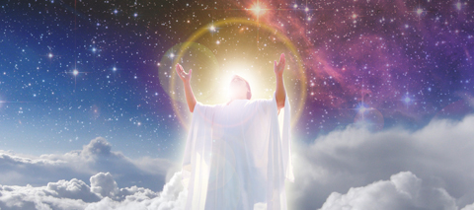

OUR SPONSOR

Our Sponsor is the Beloved Ascended Being that agreed before we came into embodiment to sponsor us during our earthly life. So this Beloved One will do all that the Cosmic Law will allow to awaken and guide us during our Earth journey, so we can fulfil our Divine Plan for our "I AM" Presence down here on Earth, which we vowed to fulfil before we came in.

If we do not fulfil the Divine Plan, due to the pulls of the Earthly senses, desires and the lack of self-control by the human, preventing the ‘still small voice within’ from being heard, then the Sponsor will have to make up for the lack (shortfall), and the misuse of life (thoughts, feelings, words and actions). They agree then to do additional service either on this planet or somewhere else in the Galaxy to make the up balance. So the Divine Beings do not sponsor any lifestream unless They have faith in the soul and feel the risk will bring the reward - so to speak.

Not all souls will be sponsored, only if they have the potential to fulfil their Divine Plan and/or assist the Earth, will an Ascended Being take on the responsibility and liability of sponsoring a lifestream, as ALL life is required to make an accounting for the energy and life it uses!

We can ask daily for our "I AM" Presence and Sponsor, to show us our Divine Plan, and give whatever the Cosmic Law will allow to assist us, so this is done. Our part of the deal is to listen for the Divine Direction and do our best to live according the immutable Universal Laws that govern our lives, and so work cooperatively with our “I AM” Presence and the Beloved Ascended One that has given a part of Their Life and Energy to assist us.

It is important to make the calls to our Sponsor - but FIRST always to our own “I AM” Presence, as ultimately none can do it for another, and only help can be given when ASKED for!

