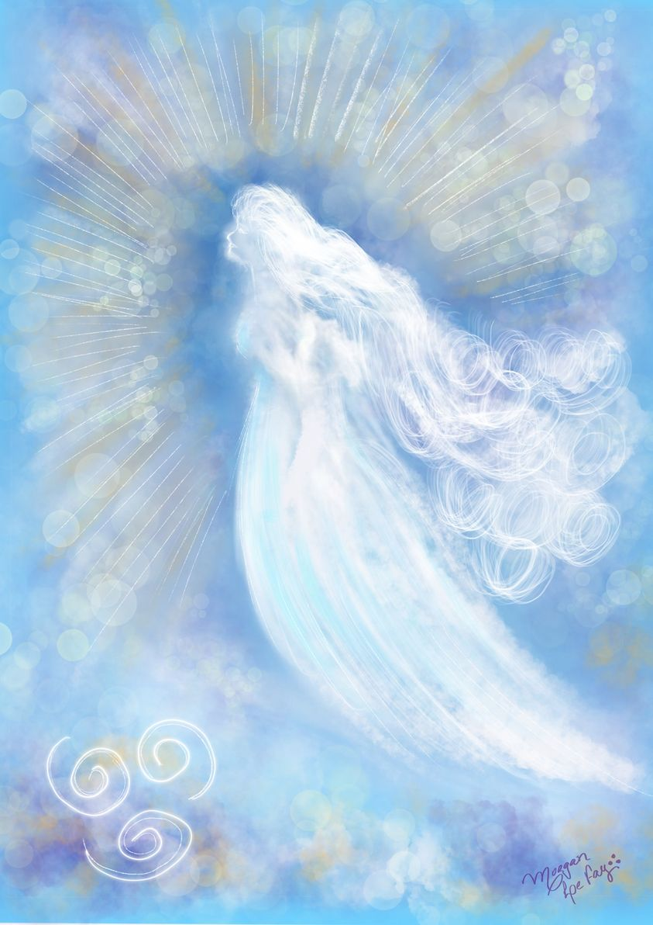

Mighty Aries
The Seven Sacred Weeks

Beloved Aries Speaks:
Beloved Thor and beloved ladies and gentlemen, we thank you so much for being interested in the atmosphere in which you abide.
I wonder how many of you have ever thought of a planet without an atmosphere! There could be no human life upon it and all the various experiments which the peoples are making regarding trips to other planets is dependent upon scientific research as to the atmosphere in, through and around those planets. Of course, scientific accuracy is not yet perfected. The understanding that every planet on which life abides has an atmosphere and that man-made atmosphere — no matter how expensive — will not suffice upon another planet!
Individuals who desire to rise in space and visit the various polaroids, stars and planets have to accelerate to their own atmosphere, and do so in the safety of projected consciousness!
We are joyous and have been ever since the great Helios and Vesta asked us to have created an atmosphere for this Earth — the light blue of the morning to the deep blue of the night, where the moon and the stars stud our garments. That is a living and palpitating essence by which you, each and every one, have life upon, this Earth. Without it there could be no life. Without the directors of all the four elements and our subjects, there could not be life upon this Earth.
If the atmosphere was removed, it would do more than all the unpleasant ideas of the atomic age to remove life from this planet, but we have not chosen so to do. No! We have adjusted our atmosphere for you, each and every one, lowering its vibratory action as the Earth became denser and giving to you as much of our air element as you can absorb.
Within that atmosphere is what you would call the “astral realm,” which is quickly being transmuted. Have you thought each and every one of you carries a personal atmosphere, which is made up of your thinking and feeling? Is that atmosphere in accord with the directors of the four elements? Is it in accord with your great and blessed benefactor, the Maha Chohan, or whatever Ascended Master Guru you represent? Or does your atmosphere vacillate? The vacillation of an individual’s atmosphere is the instability in one of the four lower bodies.
You, as individuals, have come far along life’s path so that you should learn to control your atmosphere, personally — emotionally stable, mentally alert, etherically pure and physically charged with whatever amount of light is necessary to expand the perfection of God through you — and filling that atmosphere with the warmth of love, with the power of which Thor spoke, to direct the currents of energy wheresoever they are required and not allow them to enter into your personal atmosphere, until you, in the ovoid bright, are the master control of your own atmosphere. He who has learned the control of himself, THEN he can be master of others!

Let us remember that, thinking about the sylphs, the gnomes, the salamanders and the undines, thinking about your dealings with your fellowman and all of life, remind the outer mind and consciousness, constantly, that you are IN GOD’S NAME, his holy atmosphere. Sustain it for an hour, for a day! Ask the great Michael and your sponsor, who has helped you and you will find us your friends, as we have been through the ages, and truly your servants in the Light!
On behalf of beloved Thor, myself and the sylphs of the air, we remain ever, your humble servants!
Book: Journal 5, Bridge to Freedom, printed by AMTF – Ascended Master Teaching Foundation
-
Let us call on this day of the Seven Sacred Weeks, dear hearts, the blessings of Aries to us, all human beings and all life on earth!

Mighty Aries’s Decree
“BELOVED MIGHTY I AM PRESENCE!”
We call Mighty Aries’s Air Element Authority and Victory to descend in our midst and charge our minds with her Brilliant Ideas and Inspirations of the Higher Spheres of Manifestations, during the Seven Sacred Weeks and forever!
Beloved Aries, envelop us with your Sacred Fire of Love, raising our thoughts into the Ascended Masters’ Octave of Perfection. Hold our feelings in the ease and happiness of the Air Element.
Mighty Aries, help us to bring the beauty, purity and wonders of the Ascended Masters here in this octave, so that we can breathe, live and act in that Immortal Perfection of the Seven Mighty Elohim, fulfilling our divine plan in God’s way.
By the Power of the Seven Mighty Elohim! By the Light of God that Never Fails! I command! I demand! And it’s done!
-
Invocation:
Beloved Aries, take command, hold dominion and produce your perfection in these Seven Sacred Weeks! Make this Christmas a luminous experience for all of us! Pour your Clarity on us and throughout the planet! Purify the Air Element within us and in the atmosphere of the Earth! And lift us into your World of Perfect Ideas forever! “I AM” Grateful!
-
Artwork: Morgan Le Fay

