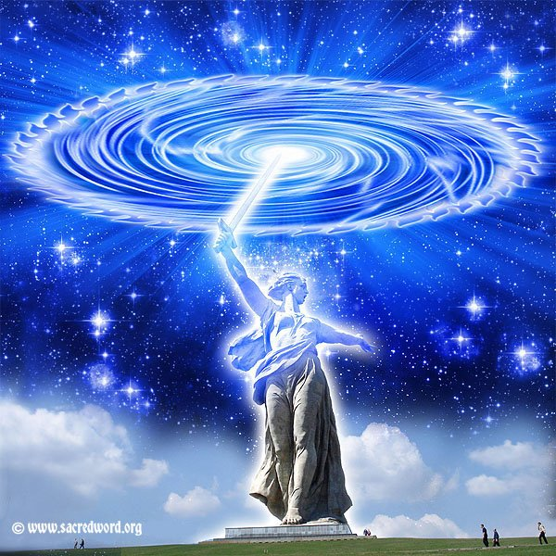
THE MIGHTY CIRCLE & SWORD OF BLUE FLAME OF BELOVED ARCHANGEL MICHAEL & ASTREA
MUSIC “MIGHTY ASTREA”
(https://www.youtube.com/watch?v=qI01QGDN4nU (3:40)
From the album "Songs to the Seven Elohim". Music and Lyrics by Robert Resetar-http://www.robertresetar.com Purchase individual song or entire album here-

READING LADY ASTREA AND LORD MICHAEL: DISCARNATES & PURITY
The very instant the Flaming Sword contacts the condition, a Circle of Blue Flame immediately forms in order to prevent the imperfection from spreading into other vortices of contamination. Will you please visualize the activity of a mighty blowtorch burning away the substance of impurity in the etheric garment where this record is stored, and the blazing emanation of the encircling activity completely surrounding the four lower garments, for all are tied into the record of distress.
You have all seen a stone cast into a lake and the resulting ripples - well, that is an infinitesimal illustration of the spreading circle, which is emitted when the Sword of Blue Flame is driven into imperfection…. Bear in mind that there is no substance in any cause and core of imperfection, which the Sword of Blue Flame cannot pierce. These causes and cores of imperfection have been around for eons of time, and we require tremendous assistance in the form of calls to go into action when there has been no effort on the part of individuals who feed these imperfections and do not clean them up The First, Fourth and Seventh Rays have been referred to by some as 'battering rams'. While that may seem appropriate, always remember whatever service you desire to render your fellow man should be clothed in Pure Divine Love.
THIS IS A CRUCIAL HOUR IN THE EARTH’S EVOLUTION, so I counsel you to be alert and let go of the human - AND LET GOD!!! It is my fervent prayer that no chela will be found wanting when the fiery Edict goes forth that all nonsense of the human must cease at that instant.
I desire now to discourse a little on the discarnates. Some chelas are still confused because it has been heretofore stated that all discarnates had been removed from the Earth; all discarnates up to the time of that Dispensation were removed. Does not common sense tell one that every minute life streams leave the physical plane of Earth there are discranates?
Please listen carefully. Directly above the Earth sphere is a realm where the discarnates abide. At the time of their appearance before the Karmic Board it is decided where they shall reside; those who do not have to return to the Earth are assigned to the Ascension Temples, which are in a realm or strata ABOVE that part of the discarnate realm where those who have to re-embody abide. In the lower strata, there are Halls of Learning where the individuals receive instruction from the various God-Free Beings; this instruction is not continuous, but for specific periods. In other words, they have free time to absorb and contemplate the instruction, which has been given. They have opportunity to visit one with another.
And very important, this is the Realm where Lord Michael, myself, and our Legions are ever on the alert for those who have not shed their nefarious practices through purification, where many sinister activities are spawned, and these individuals tie in to the Earth activities of a similar nature since they still desire to roam the world seeking the ruin of souls. A lifestream who has been engaged in malefic activities through the centuries does not go into a Temple of Learning and shed these tendencies in a flash! These individuals receive and receive instruction on the Spiritual Law until such time as their Sponsor takes them to the Karmic Board for review, and they are perhaps given the opportunity for another ‘round’ on Earth.
Please be assured that no immediate relative of a chela is in the lower strata of the discarnate realm, but in the realm where the Ascension Temples are, preparing themselves for the Ascension, if they have not already completed their purification. Of course, you may make calls for those in the Ascension Temples, as well as for those in the Lower Strata of the Discarnate Realm.
I trust this will clarify some questions in the consciousness of many earnest chelas.
One thinks of Purity as Light, or that which agrees with their present state of consciousness. Purity IS the uncontaminated release of God's Holy Energy in the manner, which was understood, in the former Golden Ages. I use the word “former” because We are on the threshold of the Permanent Golden Age, where all the evolutions will again understand the True Meaning of the Light of God.
Each of Us who have Ascended the Ladder of Evolution know that actually Purity means positive, affirmative radiation of Love Divine, which embraces nothing less than the Will of God. All know the statement that THE WILL OF GOD IS LIGHT, and certainly pure Light does not contain negativity of any kind.
I, Archangel Michael, bless each one of you.
And I want you to feel my Power and Strength flooding through each one of you.
Hail, children of Light! I bless you with the Light of God. I bless you with Courage; with Perseverance; and Constancy; Love, Wisdom, and Power; and the Faith of your belief, the Faith of what you believe in! I give you strength to that Faith.
Go forth and tell the world what you know.... and know that it is True! God bless you, each one: I Love you, and know that you can call on me at any moment and I will come - if not in person, I will send a Representative. Know that never again will you be without Protection. I Love you, my band of loyal ‘Soldiers’. Let us march together. FORWARD INTO THE LIGHT

