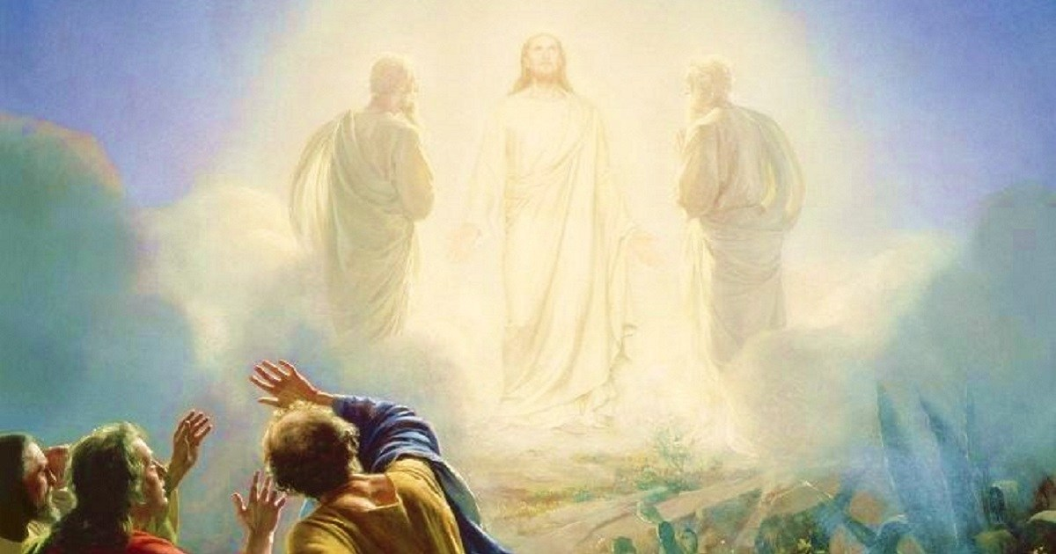

INVOKING THE FLAMES OF
RESURRECTION, TRANSFIGURATION AND ASCENSION

DAILY CEREMONY
PREPARATION: Fetch a glass of pure water. Hold the glass with both hands in front of you. Then sit with your back straight, and your legs uncrossed. Take some deep slow rhythmic breaths to slow the mind, and focus your attention on your Three-Fold Flame in your Heart and your Christ Self. Send deep Love and Gratitude to your Three-Fold Flame, your beloved Christ Self and then move your attention to your Beloved “I AM” Presence - sending deep love and gratitude to It for your Life.

Begin the Invocation holding the feeling of deep Reverence and Gratitude and visualize and feel the Great Flames as we invoke them say aloud (if possible):

(RESURRECTION FLAME)
Beloved “I AM” Presence, through Your Love, Power, and Authority I invoke Beloved Jesus The Angel of Unity, Beloved Holy Mother Mary & Archangel Raphael, Archangel Gabriel & Lady Hope and the Great Glorious Mother-of-Pearl Resurrection Flame! I invoke the Great Spirit of Resurrection and Angels of Resurrection from the Beloved Central Sun!
Expand the Beloved Resurrection Flame through the 3-fold Flame in my Heart and the Points of Light within each and every little inner-worker of my 4 Earthly bodies “

Pause, visualize and feel the Flame BLAZING in through and around your 4 earthly bodies and give LOVE & GRATITUDE to the Flame and use this statement to for the rhythmic breath 3 times – visualize and feel the Flame do its perfect work!:
“I AM” inbreathing the Mighty Power of the Resurrection Flame from the Resurrection Temple
“I AM” absorbing the Mighty Power of the Resurrection Flame from the Resurrection Temple
“I AM” expanding the Mighty Power of the Resurrection Flame from the Resurrection Temple
“I AM” projecting the Mighty Power of the Resurrection Flame from the Resurrection Temple

(TRANSFIGURATION FLAME)
Beloved “I AM” Presence, through Your Love, Power, and Authority I invoke Beloved Lady Nada, Beloved Ascended Lady Master Joyce of Transfiguration, and the Beloved Glorious Ruby and Violet Transfiguration Flame. I invoke The Great Spirit of Transfiguration and Angels of Transfiguration from the Beloved Central Sun
Expand the Beloved Transfiguration Flame through the 3-fold Flame in my Heart and the Points of Light within each and every little inner-worker of my 4 Earthly bodies “

Pause, visualize and feel the Flame BLAZING in through and around your 4 earthly bodies and give LOVE & GRATITUDE to the Flame and use this statement to for the rhythmic breath 3 times – visualize and feel the Flame do its perfect work!: :
“I AM” inbreathing the Transfiguration Flame from Beloved Lady Nada & Lady Joyce
“I AM” absorbing the Transfiguration Flame from Beloved Lady Nada & Lady Joyce
“I AM” expanding the Transfiguration Flame from Beloved Lady Nada & Lady Joyce
“I AM” projecting the Transfiguration Flame from Beloved Lady Nada & Lady Joyce

(ASCENSION FLAME)
Beloved “I AM” Presence, I invoke Beloved Serapis Bey, The Brotherhood at Luxor and Shamballa, The Great Pure White Ascension Flame! I invoke The Great Spirit of Ascension and Angels of Ascension from The Beloved Central Sun!
Expand the Beloved Ascension Flame through the 3-fold Flame in my Heart and the Points of Light within each and every little inner-worker of my 4 Earthly bodies, and through this water!

Pause, visualize and feel the Flame BLAZING in through and around your 4 earthly bodies and give LOVE & GRATITUDE to the Flame and use this statement to for the rhythmic breath 3 times – visualize and feel the Flame do its perfect work!: :
“I AM” inbreathing the Raising Power of the Ascension Flame from Beloved Serapis Bey
“I AM” absorbing the Raising Power of the Ascension Flame from Beloved Serapis Bey
“I AM” expanding the Raising Power of the Ascension Flame from Beloved Serapis Bey
“I AM” projecting the Raising Power of the Ascension Flame from Beloved Serapis Bey

TO END
Beloved “I AM” Presence and Great Beings invoked - Continually release these Three Flames in an ever intensifying Cosmic Action, in, through and around my 4 earthly bodies and through this water Resurrecting, Transfiguring, and Ascending my 4 earthly bodies to that BLAZING Christ Estate and this water to Liquid Light, the Elixir of Life! (pause and visualize) I AM Grateful!
What I call for myself, I call for my loved ones and ALL mankind!

I call for these Three Flames to be continually released from the centre of the Earth, in an ever intensifying Cosmic Action to the periphery of the psychic and astral realm, Resurrecting, Transfiguring and Ascending ALL life on this sweet Earth to a Higher State of Consciousness!

“I AM” GRATEFUL that these Three Flames are permanently anchored in all Sanctuaries and Holy Places around the world, so they become Beacons of Light, continually sending out Cosmic Rays of, Resurrection, Transfiguration and Ascension Flames, until all life on our dear Earth is Ascended and Free! AND SO BE IT – AND SO IT IS – BELOVED “I AM” - WE THANK YOU!

Then say:
“I AM” drinking Liquid Light (x3) (while drinking the water visualize the water entering your body as liquid Light and see and feel it spread throughout all your body – give deep thanks)

Do this daily until Ascended & Free!

More information on the Rhythmic Breath if needed: https://iamfree.co.za/becoming-a-conductor-of-great-light

