INITIATIONS OF THE SEVEN RAYS
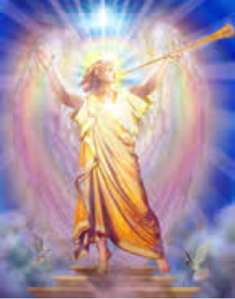

INTRODUCTION
The subject of the Ascension is discussed in detail and deals with the initiations necessary to accomplish the Ascension.
Did you ever say to yourself, as you looked back over your life, “Am I glad my school days are over! I am finally free of all those tests!” This sounds wonderful, to be sure, but that is not quite how it goes!
When our beloved Father-Mother God, Helios and Vesta, drew us forth as spirit sparks from around the Great Central Sun, they said, “We are giving you opportunity, namely the opportunity of becoming beautiful spiritual beings, just as we are. We want you to have all of the God-attributes we have—love, wisdom, power, purity, truth, peace, healing, consecration and concentration—so you can enlarge the borders of the Kingdom of God.”
As we know, nothing is achieved without self-effort, and therefore, we are sent to school, the schoolroom of the seven spheres, around our physical sun, and we spend as much time in each sphere as we wish, becoming more God-like as we progress through this, our schoolroom.
Some of the individual beings decided to stay in one of the seven spheres to serve God there. It is only the strongest who decide to pass through all seven spheres and continue to a new schoolroom, the Earth. And those who do continue on to Earth, are on the path to becoming Godheads, just like our own Father-Mother God, Helios and Vesta. All of us are on that path. We chose it!
And the interesting thing about it is, there is no turning back. We have all consciously made this momentous decision, ages ago. Some of us chose to go slowly, through many, many embodiments. Others progressed more quickly.

Download the full document on the “INITIATIONS OF THE SEVEN RAYS”:

