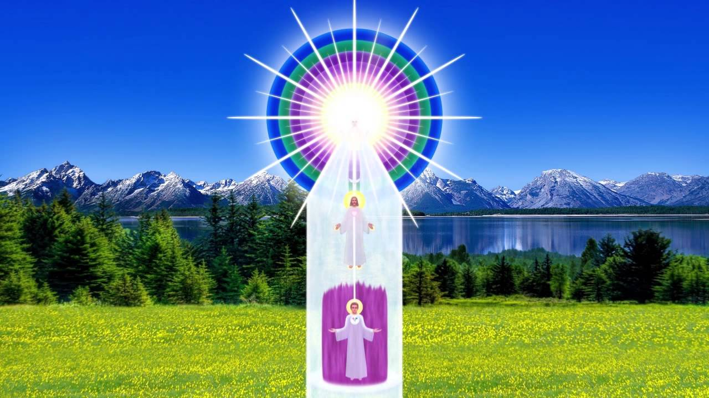
HOW TO LET THE PRESENCE ACT
An Address by Beloved Jesus

The Ashram, December 25, 1959

BRIDGE TO FREEDOM JOURNAL - APRIL 1960
On this day, celebrated as the anniversary of my humble birth, I give honor and blessings not only to angels, mankind and elemental life, but particularly to those who made my victory possible. I refer to my blessed mother, who held, throughout her lifetime, the immaculate concept for me, to my good father (Saint Joseph), now the Ascended Master Saint Germain, who leads you and succeeding generations into permanent victory, and shall bring forth the magnificence of the Golden Age.
Beloved ones, the angelic host, are truly a part of that victory, coming in their God-free estate, closer and closer to the earth plane. In every one of my own personal experiences, wherein there was temporary trial, the power of my own holy family and the angelic host gave me the feeling of victory. Even on that Thursday in Gethsemane, when I offered back my “cup,” the strength of the angels helped me to hold my cup that I might fill it on Good Friday and Easter Sunday.
You, too, now have a cup, filled with the gifts of God, and many times, even like unto myself, you desire to place your cup in the hands of the Father, not choosing to pour forth the fullness of its gifts to all mankind! What good is a cup, filled with the gifts of life eternal, if that cup, filled to the brim with our love, does not reach the souls of men, giving to them the essence of divinity, the encouragement required to progress upon life’s way and the power (latent within them) to expand their own divinity. I was but one example of what all men shall become, here on this Earth, even before the glory of their ascension. Accept that in your feelings NOW!
Carry Your Cup in Honor
That Holy Christ Flame within your hearts is able to render this service through you. Utilizing this power requires great humility of the outer self, so that the human personality shall lessen and the Christ within always be given credit for doing the good works. Now is the hour when THAT accomplishment is required. Carry your cups in honor, that all who are athirst may drink thereof.
Again, again and again have I said I have been but an example of what all men shall be, here on this Earth, even before the victory of their freedom and the glory of their ascension. Can you not accept that in your feelings, that it would be a very foolish Godhead who would create but one divine son and many sons and daughters of clay! No, everyone from every star and system, has a bursting Christus waiting to expand, but it takes great strength to allow that light to expand into and through you. It takes great humility for you to understand that, in the expansion of the light, you become less and the power acting through you becomes more. It takes great discrimination to cognize that the gifts and virtues and blessings that flow forth are of the Father within you, acting through you, true, but not to glorify the self. How often have I said, even in my ministry on Earth, “It is not I. It is the Father within that doeth the works.”
That Father-life is within you, too, willing to accomplish the works if you let it expand its power. What I have done, you can and SHALL do. NOW is the hour when that accomplishment is required, because mankind, everyone everywhere, desires the example manifest of the Christ in order to, in themselves, have the encouragement necessary to make like endeavor.
We are in the days and hours of change, true. Here upon the Earth there are many human appearances that frighten those who are not anchored in the power of God. Yet, those appearances are no greater than the appearances manifest in my ministry. In fact, except for the fact that they are televised, they are less. Where is the Christ that says unto them, “Peace be still” and then calls forth, by the power of love and light, the God-victory and manifestation that is required to make each and every one of you that manifest perfection, not only today, but so long as you shall remain on Earth and that will be part of your crown in heaven.
What Your Crown Is
Many individuals have wondered about that crown. That crown is made of all the good you have done through all the ages that you have lived. It is really the Causal Body which we wear, which the great Elohim wear, which those at the Teton wear, and which is a part of the jeweled magnificence of your victorious Presence.
There are many mansions in the Father’s home. Let your mansion be one of great light! Your mansion began when first your took embodiment upon the earth plane and into that mansion has been builded all of the good you have done through the ages. You often remember visiting them upon awakening in the morning. Through the gift of projected consciousness, enter into your mansion of light, and abide therein, feeling the play of light in and around you, enjoying the gardens of flame-flowers, and the general perfection of those realms of love in those mansions which are your own!
We are cognizant that the service rendered on the earth plane is great and that the energies involved in the sustaining of that service are many, but think you that you could even accomplish that much service, were it not for the intervention and sustenance of the Ascended Host of light? Ah no, you live truly by the power of light and the gift of love and the energy of OUR PRESENCE acting through you. So when you fold a sheet of paper, when you raise a hand in service, remember that it is the Father within and our presence that is giving the benediction and the blessing through you and practicing that you become the Christus manifest here on Earth.

Magnify the Power of the Lord
From the time of my earliest recollection, my mother taught me to magnify the power of the Lord to bless life. If we had not practiced that law of love, we would not have become the masters of energy and vibration. Even in the secular world, if one does not practice any power, he or she does not become master of its gifts and powers. Practice standing aside, humanly speaking, to allow the power of God, through you, to act! Remember always, it is God, through you, who renders the so-called miracles, even as I constantly reminded my people that it was not I, but the Father, within, which did all the works. The SAME opportunity is yours NOW. Utilize it as I did and do not let that God-power wither on the vine. Allow it to wax strong and active within and through you TODAY.
That is the activity I used in my own life, simple as it was, though it has been gloried by succeeding generations. While I walked the ways of earth there were not so many in our number, yet we practiced the using of the power of the presence of God I AM in everything that we did. In that practice, when our public mission began, I was able to utilize the momentum and the power of that Christ Presence to do the service that had to be rendered.

Practice Daily
Beloved ones, if you sat, as some of the blessed worshippers in the East, with your hand behind your back for forty years, it would wither—nature’s way, until it was permanently crippled. They think it is a devotion, yet the hands were given to utilize in practical service, and those men and women in India and China, particularly in the East, could do more with their good hands expanding the power of practical secular cleanliness and understanding and instruction than they could in allowing the arm or the foot to wither in that which they call asceticism.
NOW, where is your practice of the Presence of God - Your “I AM” Presence? You know when you have practiced, say in anything, you are proficient at it and you can do it almost automatically, whether it is playing the piano, using the type-recorded machine, as beloved Morya says, whether it is using the automobile, whatever service you are rendering becomes almost automatic and you can render that service without any consciousness of it. That is how the practice of the powers of the Presence become, until they are almost automatic in their service in and through you, for the blessing of all life.
I say this truly as one who is among you, not one who has come forth from you but one who has come to you. I lived always by the practical power of using the ever-Presence of God.
May the blessings of this holy season be upon you, radiating forth through you, to your loved ones and all upon this Earth.

HOW THE ASCENDED MASTERS CREATE
by Mary, Mother of Jesus
You are attaining great freedom and enjoying the one eternal happiness that results from becoming Master of circumstances, rather than victims of fate. The lifestreams who begin to perceive the powers of the Sacred Fire and avail themselves of the opportunity of drawing the Sacred Fire into focus, both for the purification of cosmic causes known and unknown and for the creation of new fundamental rates of vibration, are passing through the door from the realm of three dimensions, which is a prison, into the realm of cosmic cause, which is the Fourth Dimensional activity of the Ascended Masters’ Octave. It is the fulfillment of the promise of Serapis Bey, when he said you would consciously pass over the bridge into the realm of divine ideation and while yet wearing the garments of flesh you would no longer be at the mercy of your own misuse of the creative energy or that of others.

The Realm of Consciousness
You are studying consciousness and you have come to a realization that within the realm of consciousness is the cause of every effect, good and evil, that has appeared or will appear in the lifestream of the individual, but there is something ABOVE consciousness.
Consciousness is the effect of the use of the God-principle by a self-conscious intelligence who has woven out of the universal light substance an invisible aura, in which there rests the causes to which we refer. You cannot say, for fact, that man is his consciousness. Man experiences the results created by him through the use of energy and vibration, and his consciousness is the effect of his use of free will.

Consciousness is the Instrument of Creation
The consciousness is the instrument of creation. The Ascended Masters’ Consciousness is their instrument and they create, in their realm of consciousness, just as the artist creates within his workroom or studio. The brush and easel are the implements used within the studio, as are the thought and feeling faculties the implements by which consciousness is formed.

How Consciousness is Created
You have therefore a fourfold differentiation:
a) The self-conscious intelligence, which is the individuality.
b) The thought and feeling faculties, which are implements of the self-conscious intelligence.
c) The primal life energy, and
d) The finished product, which is consciousness. This is at inner levels.
The Use of the Sacred Fire
Consciousness, evolved through thought and feeling and the use of the Sacred Fire, becomes an instrument through which every idea passes into the third dimensional world to become form.
Consciousness is the conductor from the unseen to the manifest. The Ascended Master Consciousness is used by the Master within, which he creates through the faculties of thought and feeling, but in order to have his manifestation come forth into the physical appearance world, he must use the medium of some consciousness who still belongs to the vibratory action of the race, on the planet which he is assisting.

Human Consciousness and Purity
The cosmic consciousness flows through some highly-evolved pure human consciousness. Such lifestreams become cosmic conductors of divinity and you have no greater example than that of our beloved Jesus. When the Cosmic Christ entered his very pure consciousness, the two became ONE.
In my discourse yesterday, I spoke of the necessity of purifying the consciousness through which any cosmic powers may flow, for the reason that the descent of cosmic ideation through that medium would energize and vivify any accumulation through which it passes, and in order to have selfless instruments, who will allow their consciousness to be used by the Divine Beings who are, by Law, only permitted to serve through lifestreams belonging to our planet, we must be assured that these human consciousnesses are like crystal vials through which our life and light and powers might flow.

Picturization and Habit
Regarding the fundamental rates of vibration of picturization and habit, these are tremendous cores of concentrated energy, that act independently of the personal self. The intense call for the purification of these rates of vibration, known and unknown, within the lifestream, will continue your already-rapid progress toward the development of a consciousness which cannot be impinged upon by any imperfect creation.
Offering Your Consciousness to the Ascended Masters
Offering your consciousness to the Ascended Masters, as the beloved Maha Chohan explained, will allow such glorious, divine ideas to be created within the scope of your intellectual acceptance and recognition, as will amaze you. These, fed by your thought and feeling, will come forth to create with greater and greater clarity, fed with your great creative experiments.

Calling to the Beings of Purity
Continue the purification of your consciousness through the use of the Sacred Fire. Call to the Beings of Purity, and through self-conscious alertness, entertain no picture which would be like a great cloud on the cosmic currents passing through you for the freedom of all.

