HOLY CHRIST SELF - HIGHER MENTAL BODY
By Alice Schutz – Law of Life Enlightener

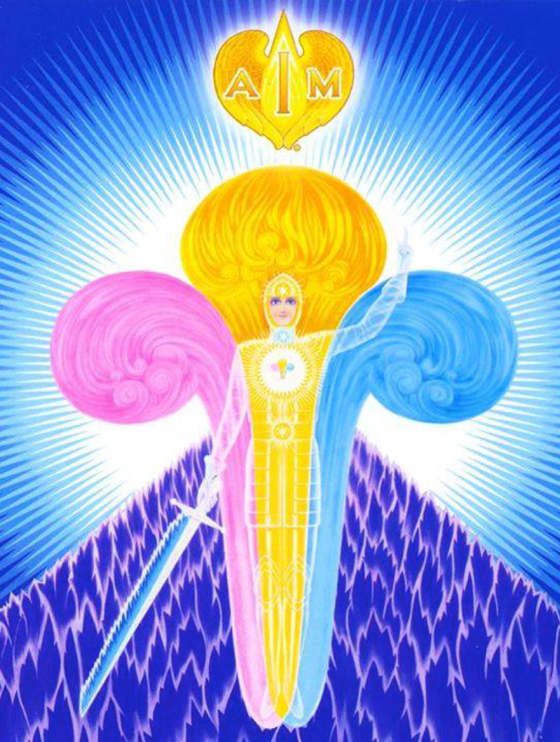

The Christ Self is beautiful, youthful and perfect. It has eternal youth and Never appears as one over 21 years of age. That is why some elderly people whose Physical body is 70 or 80 years of age, still feel young inside. The Christ Self has a flower fragrance just like an Ascended Master. The human self asserts itself and makes mistakes by using Life Energy from the “I AM PRESENCE.” Since the Christ Self is the Directing Intelligence, the student may call to It to withdraw the power the human self has given itself and refuse to accept that it has any power to make further mistakes. When dealing with others – ask your and their Christ Self for guidance. If an individual’s thoughts. Feelings, and motives are constructive the Christ Self will “Act” according to Universal Law, to bring the desired results. If it is destructive – It will not act on it. The “I AM PRESENCE” is the OWNER of everything. So It is the Intelligence, Energy, Power and Action that can take command of conditions in the outer world to provide whatever one requires.

The Christ Self is “One” with the “Presence” and is in Harmony with all Life, and
wants Perfection for the outer self. When one needs financial or other supply, [since, most are not yet Precipitating] Call to the “Presence” and The Christ of yourself and others, who are Serving the Light, who need supply; to move into action and bring about conditions in the outer world, whereby the required supply is provided. The Christ Self of every human being wants Perfection for the outer self, no Matter how destructive the activities of the personality are. The “Resistance” comes when the outer mind is given a “Truth” and resists it in the “Feelings.” This comes about when the outer self is so preoccupied with human beliefs and concepts, and will not admit there is any resistance. The student may ask for assistance while asleep, and Charge the Christ Self to Direct and Charge Its currents of energy through the Four Bodies; to Transmute, Purify and Restore their Perfection. The Christ Self has a complete and total knowledge of the outer self and its human consciousness. It is aware of every thought, feeling, motive and experience.

Although the outer self thinks and feels otherwise - it is “Impossible” to “Deceive” the Christ Self. In vibratory action the Christ Self is the Step-Down Consciousness for the “Presence” on the Fourth Dimensional Plane. The Three-Fold Flame within the Heart, Directed by the Christ Self, is the Step- Down Consciousness on the Third Dimensional Plane or the world of form. The Flame within the Heart is the “Outpost” of the Christ Self. This Flame is the embryo Christ Consciousness and can only grow in Power and Action by the Attention, Love, and Devotion given It by the outer self. When one is willing to give “All” of his or her Energy to It, then the Seed Within will grow and wax Strong - “Surrendering” the human to the Christ Self.

Beloved Master Jesus knew that even the disciples who had been closest To Him could not of themselves externalize their Christ Consciousness. Therefore, He asked for the SPIRIT OF COMFORT to be sent to His disciples, which would animate within them those Powers they had allowed to lie dormant by resting upon His accomplishments. The Beloved Lord Maha Chohan answered Jesus, and on the first Whitsuntide released those Tongues of Flame referred to in the Bible. These were actually Magnetic Currents of Energy, which Expanded the Christ Consciousness in their Soul’s and expanded the Christ Flame within their Heart’s.
The Bridegroom [as referred to in the Bible] represents the Action of one’s own Christ Self. When one has purified himself or herself enough, and can keep their Four Bodies Harmonious and at Peace at all times; then, the Christ Self can draw the Gifts, Qualities and Powers from their Causal Body and externalize them into their world. By Turning one’s Attention to and holding it on their Christ Self that Beam of Energy draws and magnifies their Divine Powers and Qualities. The Christ Self of everyone is ONE in Action. Only a small portion of the Christ Self is within the Heart, [the Golden Man within the Heart] the greater part is outside and above the physical body. When one becomes FULLY ONE with their Christ Self they are no longer of the human realm. One’s Real Mission on Earth begins when their Consciousness is no longer the “plaything” of the Four Bodies, which are transformed to become the “Servants” of the Divine Will. One’s conscience is the Action of their Christ Self. It is one’s judge! It is IN COMMAND, as opposed to the human personality, and “Decides” when to terminate life On the Earth plane. At the point of passing the individual cannot speak an untruth.

The Christ Self is not just an abstract idea, or a hazy, vapory sort of thing, but a tangible Individualization of Intelligence and Feeling. It is an INDIVIDUAL BEING OF LIGHT! When taking embodiment, the final decision is made by the Christ Self, as to who one’s Parents shall be. The moment an individual allows imperfection into his thoughts and Feelings - he has created a “separation” with his Christ Self, - which can only be corrected by dwelling on Perfection. The outer consciousness must be Purified and Developed, with Mastery and Peace Externalized, before the Christ Self can take possession of the personality.

The Ascended Masters watch and guard the students through their Christ Self. That way the students are never separated from the Master. The students are Prompted through the Christ Self of what the Masters have said. The Divine Qualities and Activities that the Masters Amplify, to benefit the Soul, must go
through the Christ Self of that one. When the “Initiate,” through centuries of righteous living, has achieved that consciousness whereby the White Dove is externalized within his or her aura, then that One is in Harmony with the Cosmic Christ and the Lord Maha Chohan. And into Their Consciousness is released
the Full Pressure and Power of Their Christ Self. Thus, the student becomes the “only begotten Son,” and his Mission, like that of the Master Jesus, is to externalize the Divine Will of God.

V.5 N.4, November-December, 29 A.F. (1983)
LAW OF LIFE ENLIGHTENER – ADK Luk

THE CHRIST SELF

The Christ Self (Higher Mental Body) is a replica of the I AM Presence. It is projected forth from the Electronic Body of the I AM Presence. The Christ Self, might be likened to a step-down transformer. Its vibrations being much slower than that of the Electronic Body. However, each
body is as tangible in its own realm or level of vibration, as a physical body is here on the physical plane. It is a Body of blazing Light, and is wholly perfect and will not accept or allow any imperfection into Its world.

The discriminative and selective intelligence acts thru the Christ Self. In the use of these Laws great discrimination is required. One’s Christ Self is his/her discriminating Intelligence. We must call it into action. One can call to the Presence for discrimination, then the Christ Self will produce and cause it to act thru the outer self it comes thru the Christ Self. That way one can keep
discordant talk and things from entering one’s world.

The Christ Self can look upon the discord around the outer self, but not accept it. It knows what is required, and can draw it forth from the I AM Presence, to produce perfection. It is the Christ – the Christ action for the outer self, for the personality.

The Christ Self embodies the qualities and activities of the I AM Presence, and can draw forth whatever light, energy, power and substance that is required from the I AM Presence, the Electronic Body, and from the Causal Body. It controls and regulates the amount and intensity of Light and Life released to and thru the outer or physical body. The Christ Self is the determining factor, as to
what can be done for that human being, and what takes place in one’s life.

The great Wisdom of Life has provided the Christ Self as the director of the currents of energy and Light which may be called forth at any time. The Christ Self can cut one free with the Sword of Blue Flame. It is all-powerful and wise, and It is the real authority over one’s lifestream. The reason one is not yet free is because the outer self did not know of the Christ Self and then when it
did (and does) it still gives more power to outer things.

The Christ Self is one’s discriminating selective intelligence and knows what one requires in his/her outer activity before the outer self is aware of it. Although one may think he/she requires certain things he/she may realize later that he/she requires something else. In knowing the Presence and making the call, impels into action the discriminating selective intelligence of Christ Self, to
provide whatever is required in the outer activity. Thus is provided directing Intelligence, the activity and conscious enfolding Presence to produce perfection in the outer.

The I AM Presence has delegated the Christ Self to have charge of and direct the outer consciousness and form. Hence, It knows the requirements and also the difficulties and troubles of the outer self, whereas the I AM Presence does not concern Itself with such things. It has given that authority to the Christ Self.

The Christ Self operates between the outer self and the Presence. Originally, It functioned in the Third Sphere, but presently abides in the Fourth Sphere for the most part. It may also abide in the Causal Body. When one maintains harmony in the outer self, then the Christ Self can
work thru the outer self. When one feels a sudden or definite harmonious action,
it may be from a Master.

One’s attributes come from the Christ Self, as well as the faculties and one’s ability to function. That is what acts thru the intellectual consciousness or outer mind, but can be colored or distorted.

The Christ Self regulates and directs the activities of the organs of the physical body, which is taken for granted until something goes wrong, or gets out of order. The outer self does not give it a thought and goes about doing what it wishes. Aside from a certain amount of gathered energy which can act involuntarily, the energy called forth is from the Presence directed by the Christ
Self.

The Christ Self keeps life flowing into the body. It is able to cause the organs to function, supply the outer self with energy and intelligence. In spite of what sort of environment one gets into, what kind of feelings one has or what kind of food and drink that is taken into the body the Christ Self has to handle it. It has the power to do it. Also it has the power and intelligence to handle any problem one might encounter. It will do so when the outer self can give all power back to It; thus let It handle it, and be at peace.

The Christ Self keeps the heart beating. It and the Body Elemental operate the functions of the body, the digestive system, etc. The organs of the physical body do not act automatically, they are under the direction of the Christ Self. When one becomes inharmonious, the Christ Self recedes from the outer self. The energy and intelligence from the Christ Self flowing thru the four
lower bodies enables one thru the senses to cognize the conditions in the outer
world (of form).

One’s heart-beat is sustained thru the flow of energy from the heart of the Central Sun, coming thru the heart of that one’s Electronic Body, and thru the heart of the Christ Self. The Christ Self regulates the amount and intensity of that flow of energy. It also sets up a plan for each lifetime, and an approximate life span for that embodiment.

For aerial transportation the Christ Self far excels any outward conveyance; even the etheric body does too.

The Christ Self having the all-knowing mind will not release energy for a destructive purpose to one who has entered upon the path of Light and has come into the knowledge of the “I AM”. However, if that one does act destructively, it is by energy already accumulated in his/her world, particularly
in the emotional body. So when that energy is exhausted that one could not continue such actions. Some people have a great momentum of mental power. But there is a difference between that and real spiritual power.

The Christ Self, of course releases the regular daily allotted amount of energy to the physical body which the outer self can misuse. But it will not release extra energy for destructive purposes. Whereas, when one has this knowledge and understanding, one can call forth whatever is required to fulfill the Divine Plan.

It is thru the Christ Self that the activity of one’s Reality can flow or express. The inner or Real Self of each one is beautiful and perfect. The Christ Self knows ahead of time what is required in the outer activity of one’s life. The outer consciousness does not know because of the density of
the brain and body. But by getting still these finer vibrations can reveal what is required.

The Christ Self of each one is the judge as to what the outer self is required to do to fulfill the Divine Plan. It has a complete record of how all the energy has been used by the lifestream from the beginning. It judges, but never criticizes or condemns.

Even though the Christ Self is all-knowing and all-powerful as far as the outer self is concerned, at times, It will call on Ascended Beings for assistance. When the outer self does not obey the directions from the Christ Self because of the accumulated human creation of the past, It calls to some Ascended Master because He has gone thru the whole process by self conscious effort, and
knows every requirement. So when the outer self is too stubborn to let the impulses from the Christ Self, thru and respond, the I AM Presence, thru the Christ Self asks for assistance. The Masters do not interfere except when the Christ Self has called for it. They give that assistance by projecting a Light Ray and dissolving and transmuting that obstruction so that the impulse from the
Christ Self can get thru.

In case the Christ Self is not permitted to release the energy, power and
action a person requires, for some purpose because of his/her discord and
interference then the Christ Self calls to an Ascended Master Who will project
His consciousness into that one’s feeling world which will act there until the
person can handle, control or accomplish what is required.
When the human is stilled one feels at peace because the current of energy
from the Presence, is not being misqualified.

The Christ Self is the governor of one’s outer self and world. It has the Power to change that and will when the outer self stops requalifying the energy
and charging that into his/her world; and also stops trying to do things thru the
human will, which is the gathered energy in the outer activity of one’s world.
Instead one should call the power of the I AM Presence, which is Light, selfluminous, intelligent substance, into action. Before going to sleep call on the
Law of Forgiveness for all mistakes.

Call to the I AM Presence, and charge the Christ Self to direct back to the
physical body, a Light Ray of healing (or whatever the requirement is), and to
dissolve and transmute all; human creation, and to see that the full action is
there upon awakening.

The Christ Self is the intelligence and power which acts at the direction of
the I AM Presence. One will never be deceived by the Christ Self.
It is possible to see the Christ Self when there is enough human creation
cleared away, and harmony is maintained in the feelings.
Since the Presence has provided the Christ Self to handle whatever comes
within the vibratory action of being embodied on a planet, the Christ Self
knows both conditions; that and also the perfection of the Presence. So when
one calls to the Presence it is the Christ Self who hears it, knows what to do
and answer that call.

Some students while asleep render service thru the Christ Self. Before
going to sleep, one can make the call: “Beloved I AM Presence, while this body
is asleep, take me in my Christ Self and see I render whatever service You
want.”

The Christ Self stands above or somewhere outside the physical body
waiting for the outer self to get to the point of self-control, whereby enough
harmony is maintained in the feelings so the Christ Self can release Its powers
thru the outer form.

The Christ Self knows the requirements of the outer self and will release it
from the Presence to produce perfection, when one has kept the feelings
harmonized long enough. In order to produce perfection in one’s activity and
world the Christ Self needs one’s energy held in control, and it must be kept
harmoniously qualified.

Instead of human beings giving advice to others, they should be turned
back to their I AM Presence. This gives opportunity to the Christ Self, to
project to the outer self Its qualities and activities.

The statement attributed to the Master Jesus, “See no man after the flesh”,
means to not be interested in any one’s mistakes or limitations. The Masters are
not, nor is the Christ Self. It was said that the Christ Self sometimes covers Its
eyes with Its hands so as not to see the iniquity of the outer self.
The power of qualification is the greatest stumbling block in attaining
perfection. Everyone has the capacity to change that by stopping such
qualifications.

The most important thing in one’s life is to make the calls to the I AM
Presence. That is the quickest way to become free, because it takes one’s own
application to attain Freedom. One can have assistance but that is only
temporary.

The Christ Self knowing all requirements of the outer self, utilizes every
opportunity to intensify one’s feeling, for the desire for one’s Freedom. This is
for the benefit of those who contact his/her world as well as for himself/herself.
Thru practice, one can gain a momentum of visualizing the Christ Self or
Luminous Presence of the Christ Self for that of an Ascended Master) stand
behind an individual, and put Its arms around the waist of that individual (the
solar plexus where the greatest amount of energy is). Do it particularly when
someone speaks unpleasantly, this can bring very good results. There is a
double action in this. Assistance is given the other person by holding control of
his energy; and the insulted one, by visualizing this would be controlling
himself, which would be very important.

