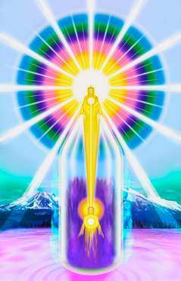

“I AM”
THE BRIDGE TO SPIRITUAL FREEDOM
Connecting with our Divine Source

VENUE (TBA)

FREE 2-DAY WORKSHOP

WE ARE IN TIMES OF GREAT CHANGE & THIS IS AFFECTING ALL LIFE ON THE EARTH
IS YOUR LIFE FULL OF CHALLENGES? ARE YOU SEEKING ANSWERS?
All information is from the Ascended Masters, who are perfected Beings that have reached the Ascended State through Their own Discipline, Dedication, Love and understanding and application of the Universal Laws that govern our lives. They are assisting humanity, and all life on Earth, to reach our next step on the evolutionary path and our ultimate goal of Freedom, The ASCENSION. Something ALL have to do one day.
Only we can free ourselves by controlling our thoughts, feelings, words and actions, and by INVOKING the Sacred Fire through our “I AM” Presence to transmute wrong habits and desires, and redeem our karma of lifetimes! To start on this journey, we need the knowledge of our own individualized “I AM” Presence, and the methods and tools shared with us by Those that are Ascended.
“I AM” THE BRIDGE TO SPIRITUAL FREEDOM Workshop:
- Opens the door to knowledge of our “I AM” Presence & the fundamental Truths and Laws of Life, thereby creating a BRIDGE between the human and the Divine.
- Methods of invoking the Sacred Fire so we can free ourselves from past karma and purify our 4 earthly bodies
- Teaches us the Ways of Light, The Immutable Universal Laws and shows us how to cooperate with the Ascended Hosts, Elementals and Angels to restore Earth to her original pristine beauty.
- Explains how our worlds are a mathematically accurate reflection of our past thoughts, feelings, words and actions, and the tools to co-create a beautiful harmonious future, and reach our Ascension, which is our Divine Destiny.
Dates:
Saturday (or a weekday) 8.45 Registration
9:00am till 15:30 Workshop
Sunday (or a weekday) 09:00am till 13.30 Workshop
Venue:
(upon confirmation of attendance a Course Outline is sent giving more details and the address)
Host:
Presenter: Anthea +27 (0) 83 227 0269 – WhatsApp/SMS iam@iamfree.co.za WEBSITE: www.iamfree.co.za Free e-Books: https://iamfree.co.za/free-books

Limited Hard copy books will be for sale at cost

Small donations may be asked to cover the cost of the venue
Further study and application is essential for results
Please RSVP ………… or ANTHEA via SMS, EMAIL or PHONE to book a place.
More information and the COURSE OUTLINE will be sent to those attending.
IF THESE DATES ARE UNSUITABLE PLEASE VISIT THE WEBSITE FOR FUTURE WORKSHOPS OR PERHAPS REQUEST ONE IN YOUR AREA

