UPON AWAKENING IN THE MORNING – EXPANDING THE THREE-FOLD FLAME
Accelerating the Vibratory Action of Your Vehicles –
AS SUGGESTED BY BELOVED LaMORAY – GREAT GOD OF HARMONY
(Source: www.pathofthemiddleway.org)
SUGGESTED DECREE:
“By the Love, Power and Authority of You my Beloved “I AM Presence”, I call directly to the BELOVED IMMORTAL THREE-FOLD FLAME within my heart – EXPAND!(X3) Your MIGHTY LIGHT saturating my Physical, Etheric, Mental & Emotional bodies with that Pure Radiance! (pause - visualize and LOVE the Light – see the 3-fold Flame expanding to a distance of 9 feet in every direction, putting your physical body in the Golden Flame - just behind your right shoulder see the PINK plume, and just behind your left shoulder see the BLUE plume – all three expanded larger than your 4 earthly bodies )
Beloved Holy Christ Self of me, USE this Light and CHARGE it with Your Mighty Power & Energy continually throughout this day! I call to Beloved……………(Ascended Master of your Choice – Perhaps relating to the Ray of the Day?) to amplify my THREE-FOLD FLAME with Your Mighty Light of ……………(name the quality or virtue you require) so This may Radiate out to BLESS all the world this day!
I Thank you, And so be it – Beloved “I AM”

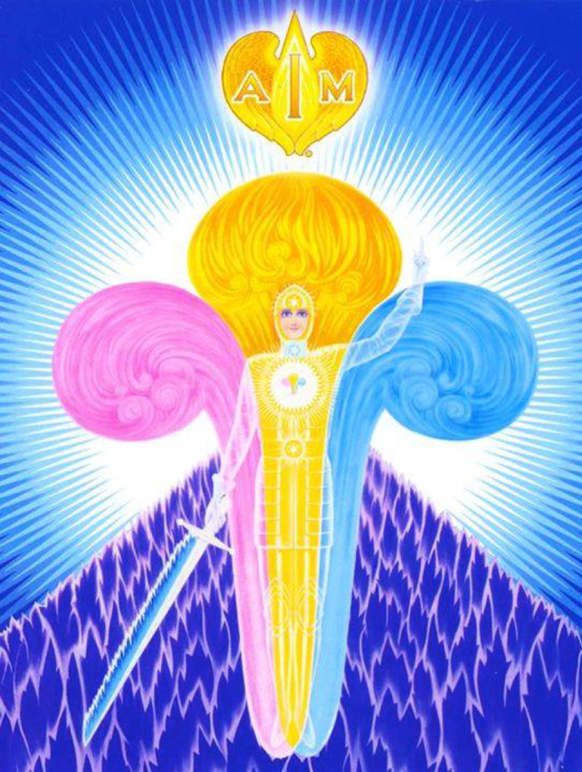

EXCERPT FROM GOD LaMOREY:
“Now, by assisting the Golden Man (Holy Christ Self) through your attention in amplifying these Three-fold Flames, you could ask some particular Ascended Master Quality to pour through the Threefold Flame to your fellowman - such as Harmony, Peace, Love, Kindness, whatever Quality you are prompted to release. If you need Purity within your own world, or Healing, ask that it be drawn through the electrons of your four lower vehicles, amplified by the Angels of Healing, Mother Mary, or the Master Jesus, Beloved Hilarion, or whoever you desire to give the assistance. In this manner you start the electrons obeying the command.
Now what happens? They begin to move at a greater speed, with greater release of the Ascended Master Quality, and they force the accumulation of discord, that which is causing you pain, out of that organ, out of those electrons. The pain is there because the electrons are not vibrating at sufficient speed to force it out of the vehicle.
In using the Violet Flame, what does it do? When you call for the Violet Flame through some particular organ, it automatically speeds the vibratory action of the electrons, and the Violet Flame dissolves that accumulation, that discord, which is in the wedges.
So you see to raise the vibratory action of your world is so simple IF you would but set the thermostat for your world when you awaken in the morning”

