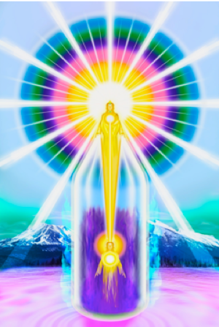
THE MAGIC “I AM” PRESENCE
“I AM” WORKSHOP
FREE ONLINE 12-SESSION INTRODUCTORY COURSE TO THE ASENDED MASTER TEACHINGS
WEBSITE: https://iamfree.co.za/

YOUTUBE: https://www.youtube.com/channel/UCoWIqDA6jimykgCpav4HToA/videos

IMPORTANT NOTES:
- All the information is from the Ascended Masters, according to the “I AM” Activity & The Bridge to Freedom material, this includes ADK Luk books.

- There will often be readings directly from the books during the sessions. The words of the Ascended Masters carry a radiation, that human words don’t carry.

- Each week a document will be sent to attendees via email covering the material we will study for the week. It is helpful to read and get the FEELING of what the Ascended Masters are wanting us to understand through their wonderful words. This suggested ‘homework’ is optional, however our constancy & dedication will determine our progress.

- Each session will be recorded, to re-listen or for missed sessions.

- There will be a few minutes allowed at the end of the session for questions & suggestions. This is for questions related specifically to the topics covered, and also spending a little time communicating with other members of the group.

- All sessions will start and finish with a few quiet moments connecting with our “I AM” Presence and invoking the Ascended Masters to Guide and Protect us through the session. A short Decree session will be added after week five.

READING THE BOOKS FROM THE ASCENDED MASTERS IS THE MOST IMPORTANT THING WE CAN DO, THEY CARRY THE RADIATION OF THE MASTERS – HERE IS THE LINK: https://iamfree.co.za/free-books

WEEK ONE
Introduction
  - Brief explanation of the intention of the Course
  - How & Why the Teachings came in and the 2 Major Dispensations

WEEK TWO
- Brief history of the Earth & the ‘fall of man’ - The Supreme importance of the hour
- The Current Cycle and Cosmic In-breath & how Sanat Kumara saved the Earth and information on Him
- The Divine Plan & our part in it!
- The Ascended Masters and who They are
- The Karmic Board and Hierarchy in the Heavenly Realms

WEEK THREE
- The “I AM” Presence
- Description of the Chart (Drawing of the Chart)
- The Power of the words “I AM” – the ‘Name’ of God
- Readings on the Power of our “I AM” Presence
- Information on Saint Germain

WEEK FOUR
- The Tube of Light – essential Protection
- The Violet Fire – The redemption of the world, and the predominant Ray

WEEK FIVE
- The Scepter & The Crown
- Remedies
- Meditation
- Decreeing

WEEK SIX
- The Laws of Life
- The Law of Harmony
- The Seven Rays
- The Power of the Light – Cosmic Light

WEEK SEVEN
- The Elemental Kingdom
- Consciously working with the Elemental – decreeing for their purification

WEEK EIGHT
- The Angelic Kingdom
- Co-creating Heaven on Earth again – Saint Germain

WEEK NINE
- The Rhythmic Breath & The Retreats of the Ascended Masters

WEEK TEN
- Group work
- Beloved El Morya – Learning through Relationships (video)
- The Transmission Flame service

WEEK ELEVEN
- Energy & vibration and the things the Ascended Masters suggest we avoid in the physical world. The 7 mortal sins.
- Chakras in the New Age - Return to the original chakra colours & their function
- Colours

WEEK TWELVE
- The Ascension – our next step on the evolutionary path
- The Spiritual Caravan
- Closing Discussion

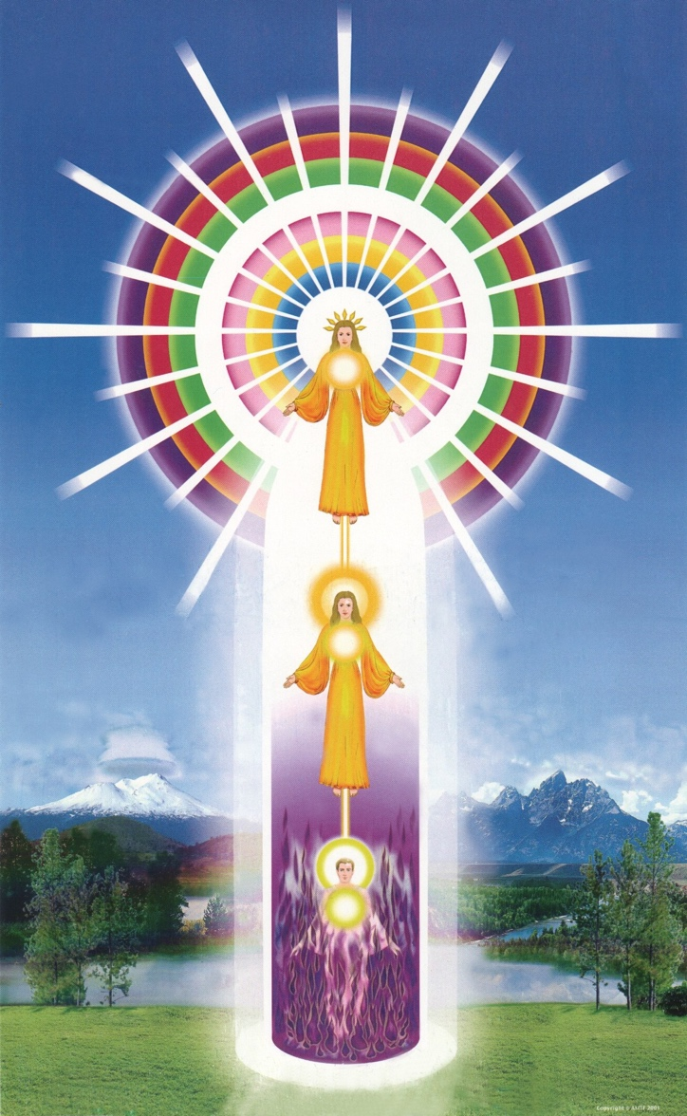
CHART OF THE “I AM” PRESENCE
(Image courtesy AMTF – Mt Shasta)
Here the colours in the Causal Body are in the correct order and the Holy Christ Self is included. This information on the order of the Rays in our Causal Bodies, was given to Geraldine Innocente and the Philadelphia Group in the 1950’s

