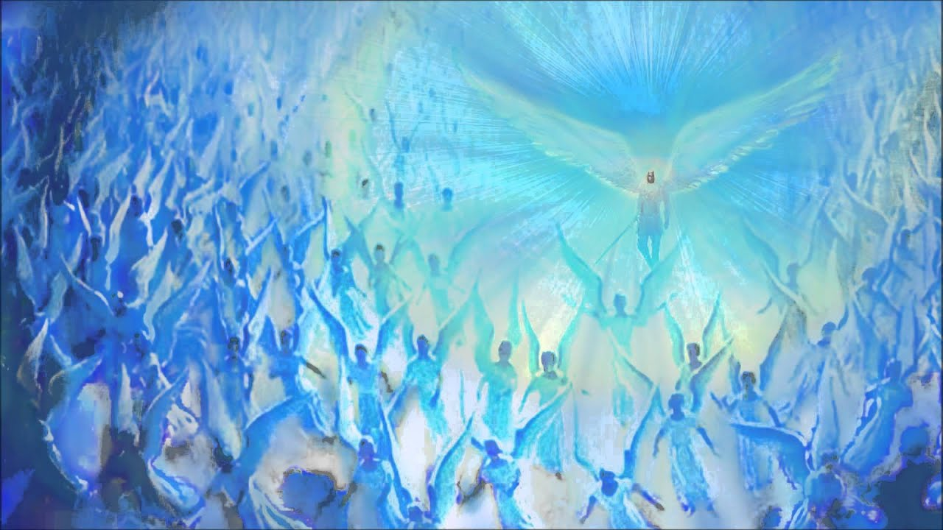

SOME OF THE WORNDERFUL ACCOUNTS OF BELOVED ARCHANGEL MICHAEL’S POWER & LOVE IN THE LIFE OF CLAUDIA, A GOOD HOPE CHELA IN CAPE TOWN, SOUTH AFRICA

In 2007 I moved into a small cottage in Camps Bay which had on-street parking. I was quite worried about my car being parked on the street and the first night at the cottage I asked Archangel Michael to protect my car during the night. When I came down to my car in the morning the car was covered in hundreds of little white feathers and, bizarrely, a full box of Marlboros on the roof! I phoned my mother to tell her what had happened and she said it was just like that movie Michael (1996) where John Travolta plays Michael as a chain-smoker! I still haven't completely figured that out!

In 2012 I went with a friend to Beaverlac in the Cederberg for a relaxing escape. The escape turned out to be anything but relaxing. We went on a hike without cell-phones and didn't tell anyone where we were. We got horribly, horribly lost, deep in the mountains. Around 2pm I made the decision that we needed to retrace our footsteps and try remember the way we came. As I was crossing a river I called on Archangel Michael to help us get out of this predicament and get back to safety. In the corner of my eyes I saw sparkling blue lights. We ended up swimming back across the river and climbing two mountains in one day and eventually coming across a road and being rescued by a passing nectarine farmer at 8pm! I have no doubt Archangel Michael was instrumental in helping us get back to safety.

In 1997 I accidentally met Diana Cooper, a lady who writes books on angels who told me I had an angel very close to me. When I went back to my car and turned the radio on, R Kelly's song I Am Your Angel was playing!

Last year around the 25th of March 2020 we were about to go into a hard lockdown and I was feeling very scared. I heard a voice in my head telling me not to be scared and that this is a time of great rejoicing! Once again, I was confused by this message as the year seemed to go distinctly ‘pear-shaped’! I can only guess that from a higher perspective all that is unfolding is worth rejoicing.

