COURSE OUTLINE
“I AM” The Bridge to Freedom
Reconnecting with our Divine Source “I AM”
VENUE
http://www.wildspiritlodge.co.za/
DATE
http://iamfree.co.za/
FREE 2-DAY WORKSHOP

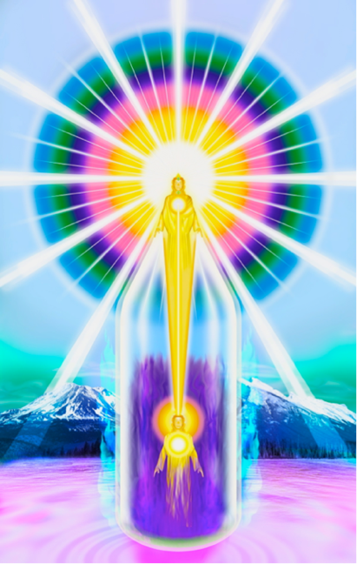
THE MAGIC “I AM” PRESENCE

“THE SOLUTION TO EVERY PROBLEM IS ALWAYS RIGHT AT HAND, BECAUSE THE
“I AM PRESENCE” ALWAYS HOLDS EVERYTHING WITHIN IT!”
Discourse XXVI – Ascended Master Saint Germain

The essence of the Ascended Master Teachings is to get everyone to understand that we are the representative of our “I AM” Presence in a physical form, The ‘Presence of God’ is WITHIN us. We are God’s and Goddess’s in embryo, and create our individual worlds with every thought, feeling, word and action. We are vested with the greatest gift of life – Freewill - and we have created our own world individually and collectively, over many, many lifetimes. The Name of God is “I AM” (“I AM” that “I AM” That is My Sacred Name” Exodus 3:14) ) and when we say those Holy Words we create with mathematical precision! The Light of the Great "I AM" is within each and every one of us, anchored in our Heart, and above us, as shown in the Chart. We chose to come to the ‘Schoolroom’ Earth, to learn mastery of our 4 lower bodies (physical, etheric, mental & emotional) and to use the Light Rays through our “I AM Presence, to expand ‘The Kingdom of Heaven on Earth’ and to Bless all Life!

Therefore, being individualized God-Beings, with the Power to create, where did we go wrong? In the realm of The God-Beings, The Ascended Masters and our “I AM” Presence, there is no discord - no fear, doubt, aging, disease, death, poverty, greed, selfishness, sadness, anger, blame or misunderstandings!

Millions of years ago, we consciously turned away from ‘The Ways of Light’ and our “I AM” Presence, which is our true Source of Life and our supplier of everything we need. We lost the use of Light Rays, which are released by our “I AM” Presence when we call them into action, and through this Light we were able to maintain permanent Happiness, Peace, Abundance, Health, Immortality and every Good thing! We became ‘sense conscious’, giving our power to the ‘outside world’ and seeking our happiness in the shifting sands of the material sensations, excesses, and often ego-driven goals that enhance self-image.

A prerequisite to self-mastery is maintaining happy and peaceful relationships with family, friends and people on our path, however equally important is the realization that our only permanent Happiness and Peace comes from our “I AM” Presence within, thus avoiding a state of co-dependency on the ‘outside world,’ which is impermanent. So the development of a close and constant relationship with our “I AM” Presence is our goal, and remaining in a state of ‘Listening Grace’ to the ‘still, small inner voice,’ often gently revealed through a feeling.

We are at a cross-road, after millions of years of Grace, The Great Cosmic Law is demanding that humanity make a final choice and individually determine our destiny. The Earth people must now ‘emit Light’ and cause our planet to shine! The old adage ‘we cannot serve two masters” is true. We are being taught now to serve the Light and co-create with our “I AM” Presence the Perfection that was always meant to be on our sweet Earth. Never again, and never before, has there been so much help from the ‘Higher Realms of Light’ as we are receiving now, so it behoves each one of us to take advantage of this.

The Ascended Hosts, in particular The Ascended Master Saint Germain, released this ancient knowledge, during the last century in an simple, easy-to-understand and apply format, as a means by which humanity can, if they choose, redeem their karma of lifetimes, through the use of the Sacred Fire (Light) in particular the VIOLET TRANSMUTING FLAME, and make the ASCENSION, which we ALL have to do one day, it is our next evolutionary step. All may now understand and abide by the Universal Laws of Life. The breaking of these Laws is the CAUSE of ALL our misery. We may choose to come again to our “I AM” Presence, learn the use of Light Rays and set ourselves eternally FREE from the wheel of birth and re-birth. As we raise ourselves, we raise all life. However, like anything in life, discipline, dedication, study and daily application are essential for the required results.
https://www.youtube.com/watch?v=Za7oVR-Q0sg
THE ETERNAL LAW OF LIFE
To understand more, please watch the above video.
A POWERFUL LIFE-ALTERING WORKSHOP – THAT WILL ONLY OPEN THE DOOR SLIGHTLY, AS CONTINUED STUDY & APPLICATION OF THE KNOWLEDGE GIVEN BY THE ASCENDED MASTER’S IN THEIR BOOKS IS ESSENTIAL TO ACHIEVE RESULTS!

COURSE MATERIAL OVER TWO DAYS
BOTH DAYS START WITH INVOCATION TO THE LIGHT AND SHORT MEDITATION

TOPICS: (Power Point Presentation is used)
DAY ONE
- BRIEF DISCUSSION: The ‘Fall of Man’, the incoming New Permanent Golden Age and the plan for the next 2000 years THE STORY OF CREATION
- If you have time, you may like to read here: https://iamfree.co.za/where-to-begin
- Description of the Chart of the Mighty “I AM” Presence - Knowledge of our own individualized “I AM” Presence, understanding the 7 bodies of mankind. - The four lower bodies, (and the essential need to purify these lower bodies) & The Three Higher Bodies.
- THE DIVINE PLAN OF SAINT GERMAIN & THE ASCENDED HOSTS WHEREBY WE MAY FREE OURSELVES & ASSIST THE BELOVED EARTH, by understanding The Laws of Life – Karma (cause & effect)
- THE LAWS OF LIFE & THE COSMIC LIGHT
- MEDITATION is the essential process that allows us to receive the direction being given to us from our “I AM” Presence and the Ascended Masters
- DECREEING - The Power of invocation
- Daily invoking the TUBE OF PROTECTIVE LIGHT
- THE VIOLET FLAME OF TRANSMUTATION from our “I AM” Presence to PURIFY & EXPAND the Light in our four lower bodies, and that of ALL mankind (we do for others until they know to do for themselves). Video on The use of the Violet Fire & the Protective Tube of Light
- PRACTICE SESSION MAKING DECREES
- LEARNING THROUGH RELATIONSHIPS (video)
DAY TWO
- THE ASCENSION (video)
- THE RHYTHMIC BREATH - knowledge and application * Health & Healing * Creating Light
- THE THREE KINGDOMS – MANKIND, ANGELS & ELEMENTALS consciously co-creating with the Angelic and Elemental Kingdoms to bring Perfection to our Beloved Earth again!
- THE ELEMENTAL KINGDOM – How we may work more consciously with the Elemental Kingdom
- THE ANGELIC KINGDOM – How we may work more consciously with the Angels
END

INFORMATION FOR THE COURSE
- If you have time, some recommended reading prior to the course can be found on the website – Where to begin:
https://iamfree.co.za/where-to-begin (NOTE: THIS IS NOT COMPLUSORY )
- The majority of the books are available on line to FREELY download for those that are happy to read on the computer/kindle or the chapters may be printed from here: https://iamfree.co.za/free-books
- For those that prefer physical books, a few are available to purchase at cost. (This is not a commercial endeavour)
- Please wear light or white colours, if possible – try to avoid black and bright red Many thanks!
- LUNCH AND TEAS - Bring and share. We suggest (optional, of course ) food be vegetarian or vegan, without garlic or onion, - this will be further explained during the course - Thank you!

Donations towards the costs of venue etc. will be greatly appreciated. There will be a bowl at the door for those in a financial position to help.

Dates: To be advised
Saturday: 08:45 Registration 09:00 - 15:30 Workshop
Sunday: 09:00 - 13.30 Workshop
Venue: To be advised
Host:
Presenter: Anthea +27 (0) 83 227 0269 – Telegram, WhatsApp or SMS.
Email: iam@iamfree.co.za

A limited selection printed books will be for sale at cost

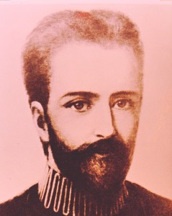
THE BELOVED ASCENDED MASTER SAINT GERMAIN

Lady Nada: “KNOWLEDGE UNUSED IS MORE DANGEROUS THAN IGNORANCE, because with knowledge comes karma and obligation to weave out of the individual’s energy a blessing to life commensurate with the knowledge received.”

